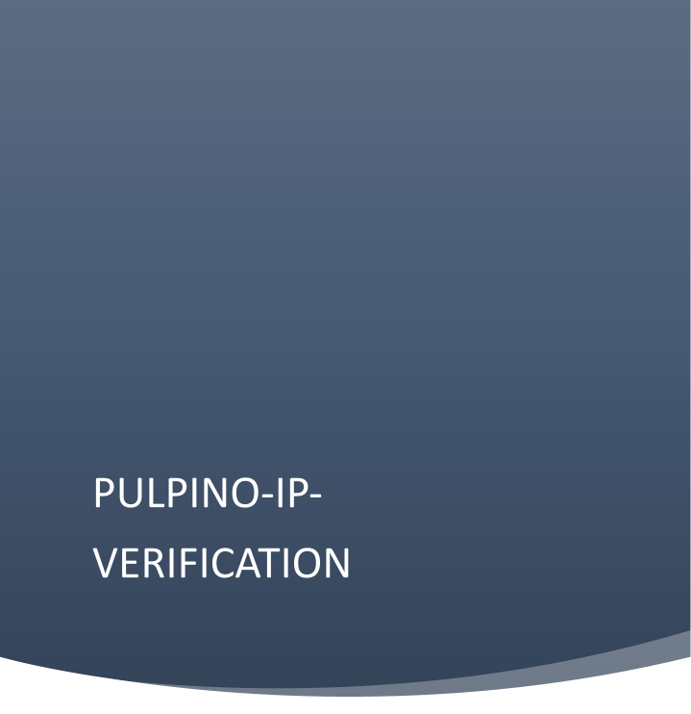

*.*

## Contents

Contents 1

List of Table 4

List of Figures 5

List of Abbreviations 8

Chapter 1 9

Introduction 9

* 1. Key features 9

Chapter 2 10

Architecture 10

* 1. Pulpino SPI Master IP Verification Testbench Architecture 10

Chapter 3 12

Implementation 12

* 1. Pin Interface 12
  2. Testbench Components 14
     1. Pulpino SPI Master IP Verification Hdl Top 14
     2. APB Interface 14
     3. SPI Interface 14
     4. APB Master Agent BFM Module 15
     5. APB Master Driver BFM Interface 15
     6. APB Master Monitor BFM Interface 16
     7. SPI Slave Agent BFM Module 16
     8. SPI Slave Driver BFM Interface 17
     9. SPI Slave Monitor BFM Interface 17
     10. Pulpino SPI Master IP Verification HVL_TOP 17
     11. Pulpino SPI Master IP Verification Environment 17
     12. APB Register Predictor 18
     13. APB Master Collector 18
     14. SPI Slave Collector 19
     15. Pulpino SPI Master IP Verification Scoreboard 19
     16. Pulpino SPI Master IP Verification Virtual Sequencer 24
     17. APB Master Agent 25
     18. APB Master Sequencer 26
     19. APB Master Driver Proxy 26
     20. APB Master Monitor Proxy 28
     21. APB Master Adapter 28
     22. SPI Slave Agent 28
     23. SPI Slave Sequencer 30
     24. SPI Slave Driver Proxy 30
     25. SPI Slave Monitor Proxy 32
     26. SPI Slave Adapter 34
     27. UVM Verbosity 34

Chapter 4 36

Directory Structure 36

* 1. Package Content 36

Chapter 5 38

Configuration 38

* 1. Global package variables 38
     1. APB Global Package Variables 38
     2. SPI Global Package Variables 38
     3. Pulpino SPI Master IP Global Package Variables 39
  2. Master agent configuration 39
  3. Slave agent configuration 39
  4. Environment configuration 40

Chapter 6 40

Verification Plan 40

* 1. Verification plan 40
  2. Registers used in Pulpino 41
  3. Template of Verification Plan 42
  4. Sections for different test scenarios 45
     1. Directed test cases 45
     2. Random test cases 45
     3. Cross test cases 46
     4. Negative test cases 46
     5. Register access test cases 47
     6. Stress test cases 47

Chapter 7 49

* 1. Template of Coverage Plan 49
  2. Functional Coverage 49
  3. Uvm_Subscriber 49
     1. Analysis export 51
     2. Write function 51
  4. Covergroup 51
  5. Bucket 52
  6. Coverpoints 53
  7. Cross coverpoints 53
     1. Illegal bins 53
  8. Creation of the covergroup 53
  9. Sampling of the covergroup 54
  10. Registers Coverage 54
  11. The methods for the sampling the values 55
  12. Enabling and sampling the coverage 56
  13. Coverage of all the Register and the memories 56
  14. Method for sampling 57
  15. Checking for the coverage 57
  16. Excluding the bins and covergroup with and without the command line 59

Chapter 8 60

Test Cases 60

* 1. Test Flow 60
  2. Test Cases Flowchart 60
  3. Transaction 61
     1. Master_tx 62
     2. Slave_tx 64
  4. Sequences 64
     1. Bus Sequences: 64

Methods: 64

* + 1. Register Sequences 69

Methods: 69

* 1. Virtual Sequences 74
  2. Test Cases 79
  3. Testlists 84

Chapter 9 86

User Guide 86

Chapter 10 87

References 87

## List of Table

|  |  |  |
| --- | --- | --- |
| **Table No** | **Name of the Table** | **Pg No** |
| Table 3.1 | APB pins used to interface to external devices………………..……… | 13 |
| Table 3.2 | SPI pins used to interface to external devices…………………….…. | 14 |
| Table 3.3 | UVM Verbosity Priorities………………………………………….….. | 35 |
| Table 3.4 | Descriptions of each Verbosity level…………………………………. | 36 |
| Table 4.1 | Directory path…………………………………………………………. | 38 |
| Table 5.1 | APB Global package variables…………...…………………………… | 39 |
| Table 5.2 | SPI Global package variables…………...…………..………………… | 39 |
| Table 5.3 | APB Master_agent_config…………………………………………..… | 40 |
| Table 5.4 | SPI Slave_agent_config………………………………………………. | 40 |
| Table 5.5 | Env_config…………………………………………………………….. | 41 |
| Table 6.4.1 | Checking coverage closure for No of bits transfers…………………… |  |
| Table 8.1 | Sequence methods…………………………………………………….. |  |
| Table 8.2 | Describing master and slave sequences………………………………. |  |
| Table 8.3 | Describing virtual sequences…………………………………………. |  |
| Table 8.4 | Testlists……………………………………………………………… |  |

## List of Figures

|  |  |  |
| --- | --- | --- |
| **Fig no** | **Name of the Figure** | **Pg no** |
| Fig 2.1 | Pulpino_SPI_Master_IP_Verification AVIP Architecture | 11 |
| Fig 3.1 | HDL top | 14 |
| Fig 3.2 | APB driver bfm instantiation in apb master agent bfm code snippet | 15 |
| Fig 3.3 | APB monitor bfm instantiation in apb master agent bfm code snippet | 16 |
| Fig 3.4 | APB driver bfm instantiation in apb slave agent bfm code snippet | 17 |
| Fig 3.5 | APB monitor bfm instantiation in apb slave agent bfm code snippet | 17 |
| Fig 3.6 | HVL top | 18 |
| Fig 3.7 | APB Master Collector | 19 |
| Fig 3.8 | Connection of the analysis port of the monitor to the scoreboard analysis fifo | 20 |
| Fig 3.9 | Declaration of slave & master analysis port in the slave & master monitor proxy | 21 |
| Fig 3.10 | Declaration of analysis port and import in the apb master collector | 21 |
| Fig 3.11 | Declaration of analysis port and import in the spi slave collector | 21 |
| Fig 3.12 | Declaration of master & slave analysis fifo in the scoreboard | 21 |
| Fig 3.13 | Creation of the master & slave analysis port | 22 |
| Fig 3.14 | Connection done between the analysis port & analysis fifo export in the env | 22 |
| Fig 3.15 | Use of get method to get the packet from monitor analysis port | 22 |
| Fig 3.16 | The comparison of the master pwdata with slave pwdata | 23 |
| Fig 3.17 | Flow chart of the scoreboard run phase | 24 |

|  |  |  |
| --- | --- | --- |
| Fig 3.18 | Flow chart of scoreboard report phase | 25 |
| Fig 3.19 | APB master agent build phase code snippet | 26 |
| Fig 3.20 | APB master agent connect phase code snippet | 27 |
| Fig 3.21 | Flow chart of communication between apb master driver proxy & apb master driver bfm | 28 |
| Fig 3.22 | Run phase of apb master driver proxy code snippet | 28 |
| Fig 3.23 | Flow chart of communication between apb master monitor proxy & apb master monitor bfm | 29 |
| Fig 3.24 | APB slave agent build phase code snippet | 30 |
| Fig 3.25 | APB slave agent connect phase code snippet | 31 |
| Fig 3.26 | Flow chart of communication between apb slave driver proxy & apb slave driver bfm | 32 |
| Fig 3.27 | Run phase of apb slave driver proxy code snippet | 33 |
| Fig 3.28 | Flow chart of communication between apb slave monitor proxy & apb slave monitor bfm | 34 |
| Fig 3.29 | Run phase of apb slave driver proxy code snippet | 35 |
| Fig 4.1 | Package Structure of APB_AVIP | 37 |
| Fig 6.3.1 | Verification plan template |  |
| Fig 7.1 | UVM subscriber |  |
| Fig 7.2 | Monitor & coverage connection |  |
| Fig 7.3 | Write function |  |
| Fig 7.4.1 | covergroup |  |
| Fig 7.4.2 | option.per_instance |  |
| Fig 7.4.3 | Option comment |  |
| Fig 7.4.4 | Bucket |  |
| Fig 7.5 | Coverpoint |  |
| Fig 7.6 | Cross coverpoint |  |
| Fig 7.7 | Creation of covergroup |  |
| Fig 7.8 | Sampling of the covergroup |  |
| Fig 7.9.1 | Simulation log file path |  |
| Fig 7.9.2 | Coverage report path |  |
| Fig 7.9.3 | HTML window showing all coverage |  |
| Fig 7.9.4 | All coverpoints present in the covergroup |  |
| Fig 7.9.5 | Individual coverpoint hit |  |
| Fig 8.1 | Test flow |  |

|  |  |  |
| --- | --- | --- |
| Fig 8.2 | APB test cases flowchart |  |
| Fig 8.3 | Constraint for pselx and transfer_size |  |
| Fig 8.4 | do_compare method |  |
| Fig 8.5 | do_copy method |  |
| Fig 8.6 | do_print method |  |
| Fig 8.7 | Flow chart for sequence methods |  |
| Fig 8.8 | Master seq body method |  |
| Fig 8.9 | Slave seq body method |  |
| Fig 8.10 | Virtual base sequence |  |
| Fig 8.11 | Virtual base sequence body |  |
| Fig 8.12 | Virtual 8bit sequence body |  |
| Fig 8.13 | Base test |  |
| Fig 8.14 | Setup env_cfg |  |
| Fig 8.15 | Master_agent_cfg setup |  |
| Fig 8.16 | Slave_agent_cfg setup |  |
| Fig 8.17 | Example for 8bit test |  |
| Fig 8.18 | Run_phase of 8bit_test |  |

## List of Abbreviations

|  |  |
| --- | --- |
| **Abbreviation** | **Description** |
| uvm | universal verification methodology |
| apb | advanced peripheral bus |
| avip | accelerated verification intellectual property |
| hdl | hardware descriptive language |
| hvl | hardware verification language |
| bfm | bus functional model |
| tlm | transaction level modelling |
| pclk | System clock |

### Chapter 1

# Introduction

PULP(Parallel Ultra Low Power) IP(Intellectual Property) is a reusable IP system that consists of the peripherals APB and SPI. It supports both the RISC-V RI5CY and zero-risc v core.

The SPI master Pulpino IP is a low frequency device that uses an APB bus of 32 bits wide as a bridge to connect to the SPI master. For data-storage, the IP uses a memory-map which will be controlled by the assigned addresses. It includes a FIFO to store the data that is received and needs to be transmitted via the TX and RX registers. It contains an event unit that can put the core to sleep and wake it up when there is an event or interrupt from a peripheral.

#### Key features

* + 1. Standard SPI mode
    2. Full Duplex System
    3. Single master SPI and single slave SPI
    4. Single master APB and single slave APB
    5. Serial transfer in SPI
    6. Clock divider
    7. Asynchronous active low hard reset
    8. Software reset
    9. SPI transfer length
    10. Appending Dummy Data
    11. Separate TXFIFO and RXFIFO
    12. Interrupt Configuration

### Chapter 2

# Architecture

#### Pulpino SPI Master IP Verification Testbench Architecture

The accelerated VIP has divided into the two top modules as HVL and HDL top as shown in the fig 2.1. The whole idea of using Accelerated VIP is to push the synthesizable part of the testbench into the separate top module along with the interface and the RTL. so, it is named HDL TOP and the unsynthesizable part is pushed into the HVL TOP. As it provides the ability to run the longer tests quickly. This particular testbench can be used for the simulation as well as the emulation based on mode of operation.

[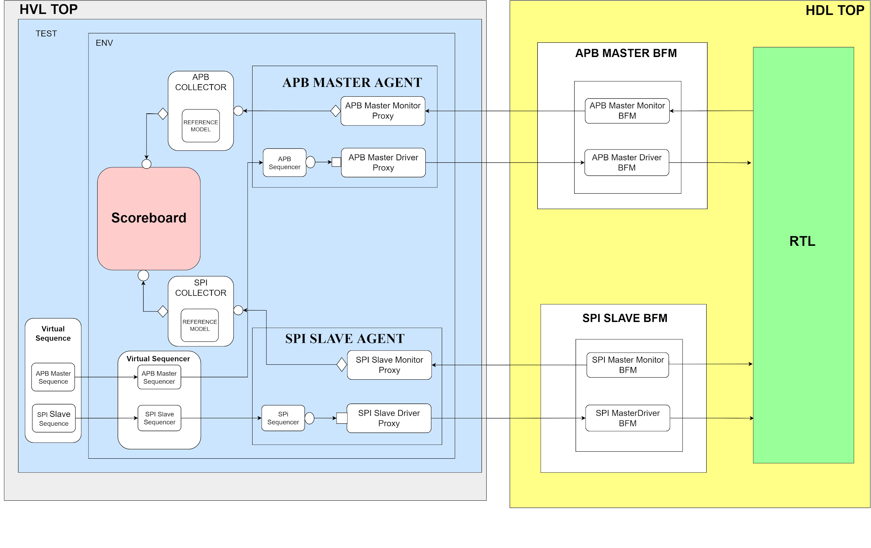](https://app.diagrams.net/?page-id=SvLTNw_i6XwuxbR4QLKc&scale=auto&G1QwzHuIm6HS289p_h2dJ8CPvWfZVdXABU)

**Fig 2.1** Pulpino_SPI_Master_IP_Verification AVIP Architecture

HVL TOP has the design which is untimed and the transactions flow from both master virtual sequence and slave virtual sequence onto the APB and SPI I/F through the BFM Proxy and BFM and gets the data from monitor BFM and uses the data to do checks using scoreboard and coverage.

HDL TOP consists of the design part which is timed and synthesizable, Clock and reset signals are generated in the HDL TOP. Bus Functional Models (BFMs) i.e synthesizable part of drivers and monitors are present in HDL TOP, BFMs also have the back pointers to its proxy to call non-blocking methods which are defined in the proxy.

Tasks and functions within the drivers and monitors which are called by the driver and monitor proxy inside the HVL. This is how the data is transferred between the HVL TOP and HDL TOP.

HDL and HVL uses the transaction based communication to enable the information rich transactions and since clock is generated within the HDL TOP inside the emulator it allows the emulator to run at full speed.

.

### Chapter 3

# Implementation

#### Pin Interface

Table 3.1 and 3.2 shows the APB pins and SPI pins respectively used to interface to external devices.

|  |  |  |
| --- | --- | --- |
| **Signals** | **Source** | **Description** |
| pclk | Clock source | Clock. The rising edge of PCLK times all transferon the APB. |
| preset_n | System bus equivalent | Reset. The APB reset signal is active low. This signal is normally connected directly to the system bus reset signal |
| paddr | APB bridge | Address. This is the APB address bus.It can be up to 32 bits wide and is a data access or an instruction access. |
| pprot | APB bridge | Protection type. This signal indicates the normal, privileged, or secure protection level of the transaction and whether the transaction is a data access or an instruction access. |
| pselx | APB bridge | Select. The APB bridge unit generates this signal to each peripheral bus slave. It indicates that the slave device is selected and that a data transfer is required. There is a pselx signal for each slave. |
| penable | APB bridge | Enable. This signal indicates the second and subsequent cycle of an APB transfer. |
| pwrite | APB bridge | Direction. This signal indicates an APB write access when HIGH and an APB read access when LOW. |
| pwdata | APB bridge | Write data. This bus is driven by the peripheral bus bridge unit during the write cycle when pwrite is HIGH. This bus can be up to 32 bits wide. |
| pstrb | APB bridge | Write strobes. This signal indicates when byte lanes to update during a write transfer. There is one write strobe for each eight bits of the write data bus. Therefore, pstrb[n] corresponds to pwdata[(8n+7):(8n)]. Write strobes must not be active during a read transfer. |
| pready | Slave interface | Ready. The Slave uses this signal to extend an APB transfer. |
| prdata | Slave interface | Read Data.The selected slave drives this bus during read cycles when pwrite is LOW. This bus can be up to 32-bits wide. |
| pslverr | Slave interface | This signal indicates a transfer failure. APB peripherals are not required to support the pslverr pin. This is true for both existing and new APB peripheral designs. Where a peripheral does not include this PIN then the appropriate input to the APB bridge is tied LOW. |

**Table 3.1** APB pins used to interface to external devices

|  |  |  |  |  |
| --- | --- | --- | --- | --- |
| **Signal** | **Master Direction** | **Slave Direction** | **Width of the signal** | **Description** |
| pclk | input | input | 1 bit | System generated clock |

|  |  |  |  |  |
| --- | --- | --- | --- | --- |
| areset_n | input | input | 1 bit | It is an active low reset generated by system |
| cs_n | input | input | Based on NO_OF_SLAVES  parameter | Active low chip select signal is used to select the slave(s). Each bit is for one slave selection. |
| sclk | input | input | 1 bit | Clock signal to synchronise the transfer of data |
| mosi0 | output | input | 1 bit | Data which is output of master |
| mosi1 | output | input | 1 bit | Data which is output of master |
| mosi2 | output | input | 1 bit | Data which is output of master |
| mosi3 | output | input | 1 bit | Data which is output of master |
| miso0 | input | output | 1 bit | Data which is output of slave 0 |
| miso1 | input | output | 1 bit | Data which is output of slave 1 |
| miso2 | input | output | 1 bit | Data which is output of slave 2 |
| miso3 | input | output | 1 bit | Data which is output of slave 3 |

**Table 3.2** SPI pins used to interface to external devices

#### Testbench Components

The testbench components of the pulpino spi master ip verification-avip are discussed below.

##### Pulpino SPI Master IP Verification Hdl Top

[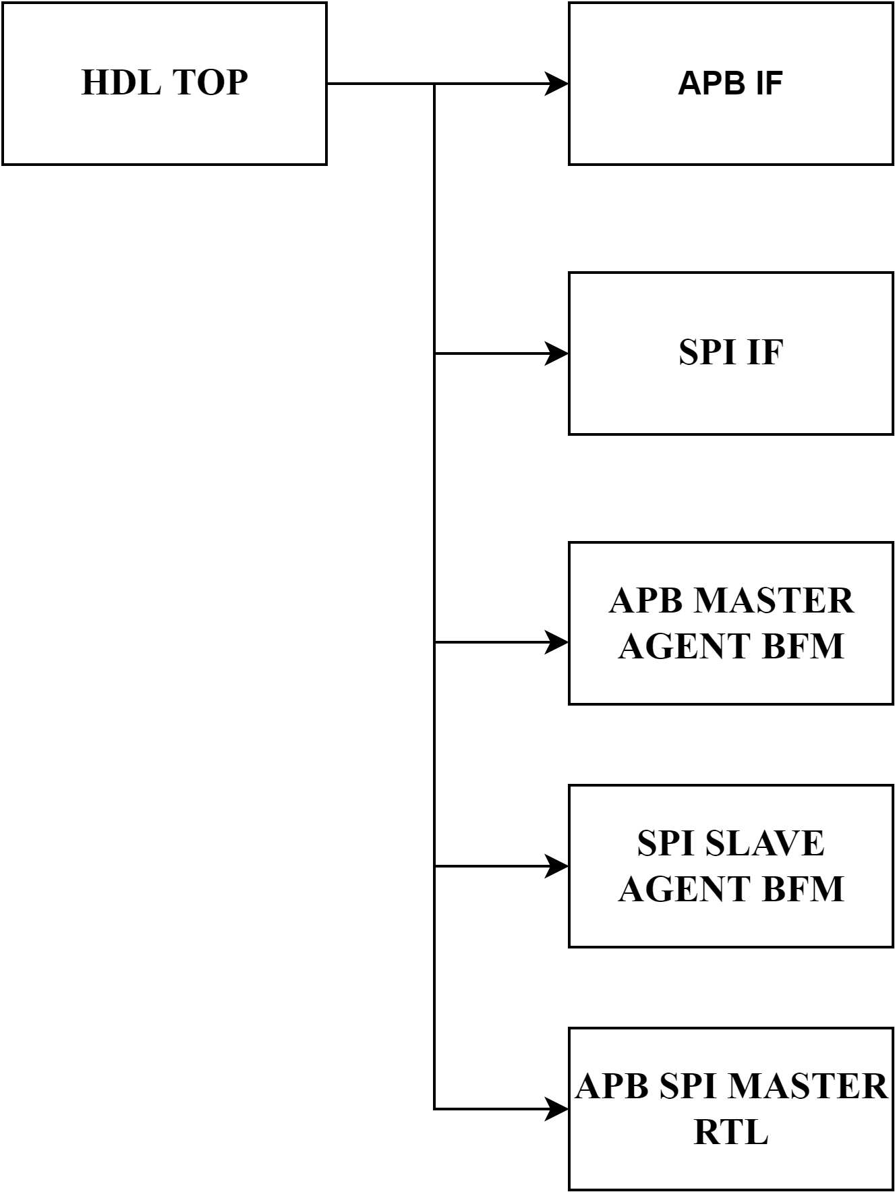](https://app.diagrams.net/?page-id=TGB1SqRiNYHYYDXISoV_&scale=auto&G1PC1yR2-kxgUWAhRNraSqxpQma84xHmeD)Hdl top is synthesizable, where generation of the clock and reset is done. Instantiation of the apb interface handle, master agent bfm handle and slave agent bfm handle is done as shown in Figure 3.1.

**Fig. 3.1** HDL Top

* + 1. **APB Interface** Importing the global packages Passing Signals: pclk, preset_n

Declaration of signals: paddr, pwrite, pwdata, pstrb, penable, pready, prdata, pslverr, pprot are declared as logic type.

##### SPI Interface

Importing the global packages Passing Signals: pclk, areset

Declaration of signals: sclk, cs[], mois0, miso0, mosi1, miso1, mosi2, miso2, mosi3, miso3 are declared as logic type.

##### APB Master Agent BFM Module

Instantiates the below two interfaces here

* + - 1. apb master driver bfm and
      2. apb master monitor bfm.

Instantiates the apb master assertions and binds it with the apb master monitor bfm handle and maps the signals of apb master assertions with the apb interface signals. The apb interface signals are passed to the apb master driver and monitor bfm in instantiations.

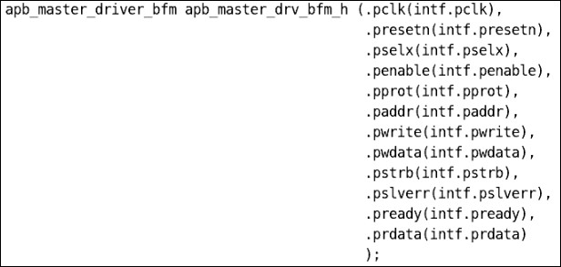

**Fig. 3.2** APB driver bfm instantiation in apb master agent bfm code snippet

Fig. 3.2 and 3.3 are the code snippets of instantiations of apb master driver and monitor bfm

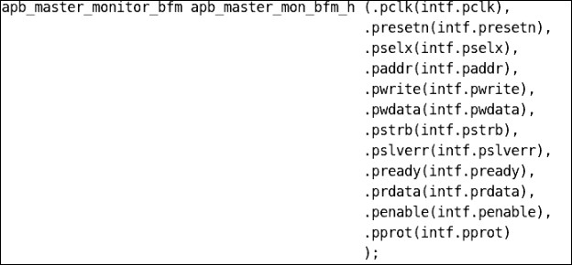*.*

**Fig. 3.3** APB monitor bfm instantiation in apb master agent bfm code snippet

##### APB Master Driver BFM Interface

Apb master driver bfm is an interface where it will get the signals from the apb interface. It has a method drive_to_bfm which will be called by the apb master driver proxy which drives the paddr and pwdata data to the apb interface. fig.3.2 gives the reference of the instantiation of apb master driver bfm.

##### APB Master Monitor BFM Interface

Apb master monitor bfm is an interface where it will get the signals from the apb interface. It has a method sample_data which will be called by the apb master monitor proxy which samples the paddr, pselx, pwdata and prdata data from the apb interface. After sampling the data, the apb master monitor bfm interface sends the data to the apb master monitor proxy using the output port of sample_data task. fig.3.3 gives the reference of the instantiation of apb master monitor bfm.

##### SPI Slave Agent BFM Module

Instantiates the below two interfaces here

1. spi slave driver bfm and
2. spi slave monitor bfm.

Instantiates the spi slave assertions and binds it with the spi slave monitor bfm handle and maps the signals of spi slave assertions with the spi interface signals. The spi interface signals are passed to the spi slave driver and monitor bfm in instantiations

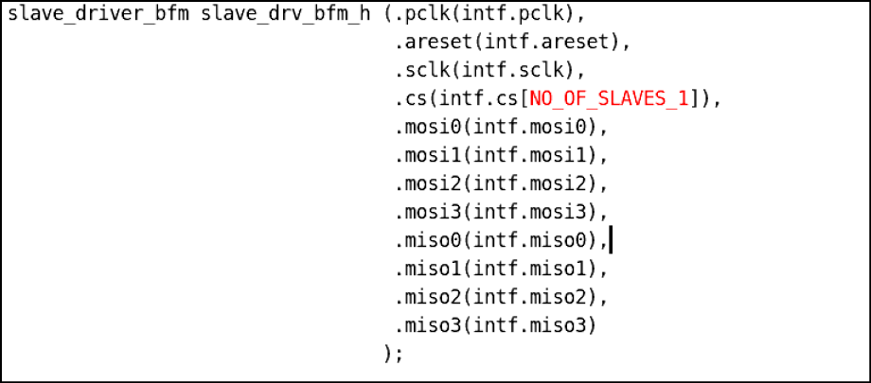

**Fig 3.4** Spi slave driver bfm instantiation in spi slave agent bfm code snippet

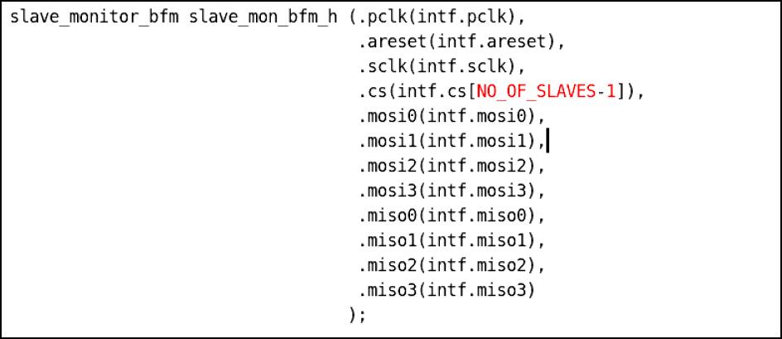

**Fig 3.5** Spi slave monitor bfm instantiation in spi slave agent bfm code snippet

##### SPI Slave Driver BFM Interface

Spi slave driver bfm is an interface where it will get the signals from the spi interface. It has a method drive_to_bfm(data_packet, configuration packet) which will be called by the spi slave driver proxy which drives the mosi data to the spi interface. fig.3.4 gives the reference for the instantiation of spi slave driver bfm.

##### SPI Slave Monitor BFM Interface

Spi slave monitor bfm is an interface where it will get the signals from the spi interface. It has a method sample_data(data_packet, configuration packet) which will be called by the spi slave monitor proxy which samples the mosi and miso data from the spi interface. After sampling the data, the spi slave monitor bfm interface sends the data to the spi slave monitor proxy using the output port of sample_data task. fig.3.5 gives the reference for the instantiation of spi slave monitor bfm.

##### Pulpino SPI Master IP Verification HVL_TOP

[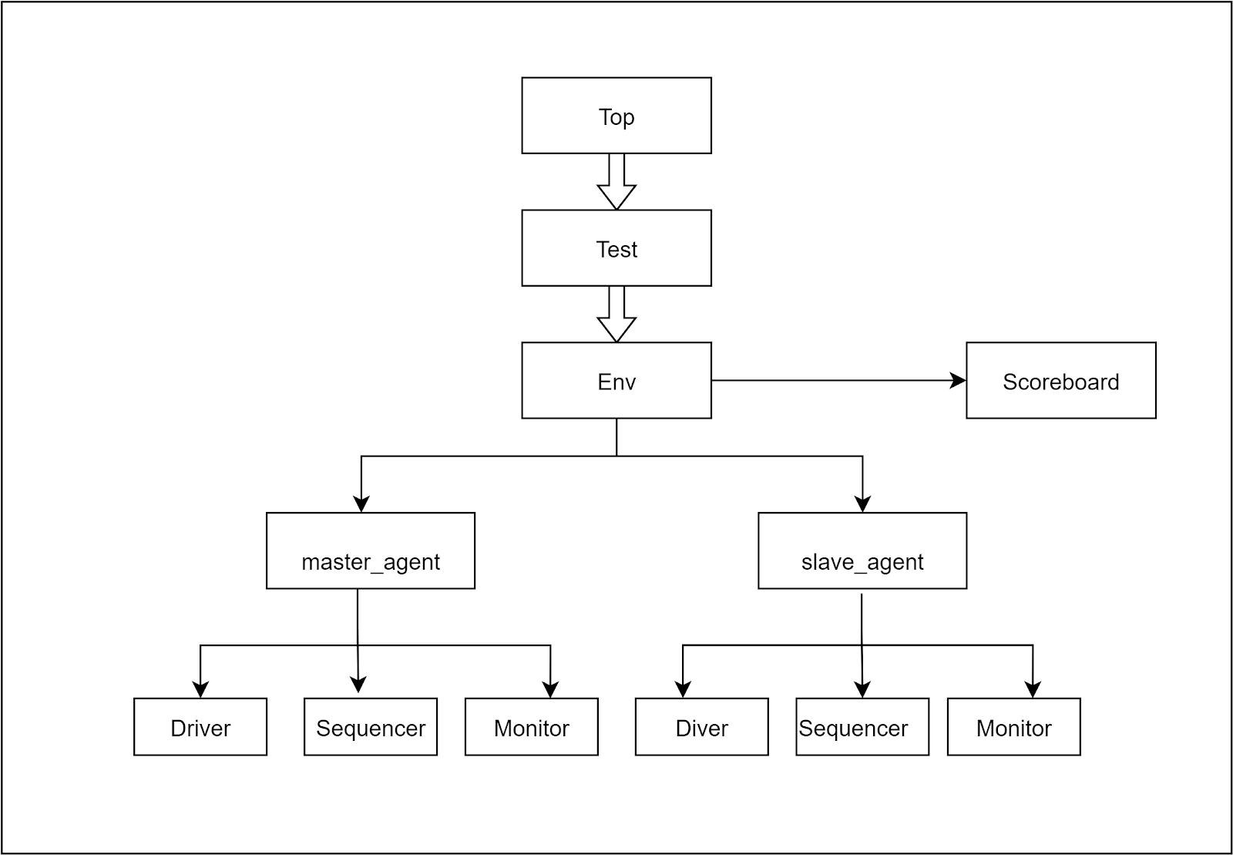](https://app.diagrams.net/?page-id=_jmjlmaAvuH_jIDzIorL&scale=auto&G1rFanZjCCt9TPdiR4eGwi4cOU_VG1e1so)

**Fig 3.6** HVL Top

In top test is running by using the **run_test(“test_name”)** method, which will start the whole tb components.

##### Pulpino SPI Master IP Verification Environment

Environment has the below components

1. pulpino_spi_master_ip_verification_scoreboard
2. pulpino_spi_master_ip_verification_virtual_sequencer
3. apb_master_agent
4. spi_slave_agent
5. apb_master_collector
6. spi_master_collector
7. apb_reg_predictor

In the build phase, env_cfg handle will be called and create the memory for the above declared components.

In the connect phase, the apb_master_monitor_proxy is connected to apb_master_collector using uvm analysis port of apb_master_monitor_proxy to uvm analysis import of apb_master_collector. The apb_master_collector is connected to the pulpino_spi_master_ip_verification_scoreboard using tlm_fifo of pulpino_spi_master_ip_verification_scoreboard and analysis_port of apb master collector. The spi_slave_monitor_proxy is connected to spi_salve_collector using uvm analysis port of

spi_slave_monitor_proxy to uvm analysis import of spi_salve_collector. The apb_master_collector is connected to the pulpino_spi_master_ip_verification_scoreboard using tlm_fifo of scoreboard and analysis_port of apb master collector. as shown in fig 3.7. The reg_map inside the env_config is passed to the apb_master_collector and apb_reg_predictor. The apb_master_adapter is connected to the adapter in apb_reg_predictor.

##### APB Register Predictor

APB register predictor component is used to find the register sampled from the monitor proxy to send to the coverage sampling using RAL. The APB reg predictor calls the bus2reg method to convert the apb bus leve transaction to register level transaction so that it can be passed to coverage sampling.

##### APB Master Collector

[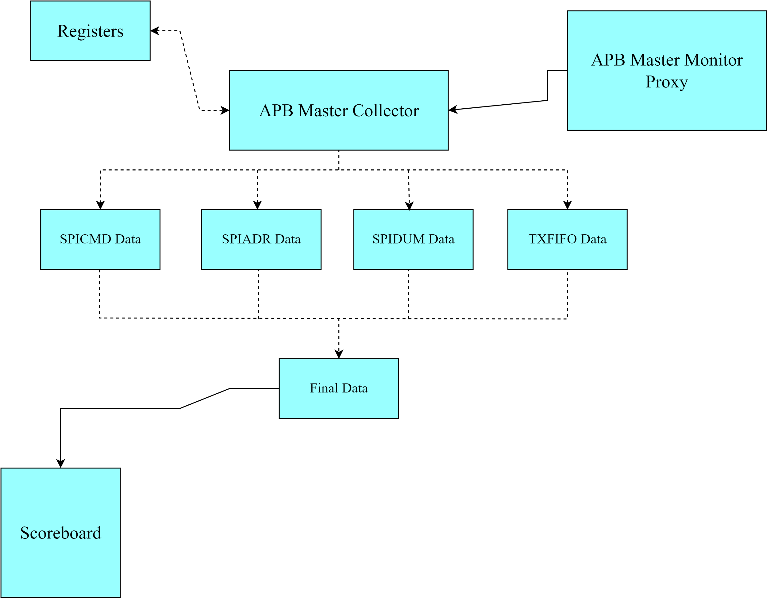](https://app.diagrams.net/?page-id=BDAUyr6MT5B_IiJ74yIf&scale=auto&G1qyMdPZzfhDTVKYBV6DzOmuLoXPkaxBH8)APB master collector component is used to sample the apb master monitor proxy sent data and access the registers using the address sent in the respective transaction and gets the data of the command_register, address_register, dummy_register and tx_fifo register. It concatenates all the four registers data in the respective order i,e., command, address ,dummy data ,tx_fifo data. This concatenated data is stored into the pulpino_spi_master_ip_global_pkg’s coll_pkt struct packet. This coll_pkt struct packet is passed to the scoreboard for the comparisons. This process is shown in the below figure 3.7

**Fig 3.7** APB Master Collector

##### SPI Slave Collector

APB master collector is a component which samples the data from the spi slave monitor proxy and sends the data to the scoreboard for the comparisons.

##### Pulpino SPI Master IP Verification Scoreboard

A scoreboard is a verification component that contains checkers and verifies the functionality of a design. The scoreboard is implemented by extending uvm_ scoreboard.

The purpose of the scoreboard in the pulpino spi master ip verification-AVIP project is to

1. Compare the data from the slave and master
2. The compared data is concatenation of command, address, dummy cycles and tx_fifo data.
3. Keep track of pass and failure rates identified in the comparison process
4. Report comparison success/failures result at the end of the simulation

The scoreboard consists of two analysis fifo’s which receive the packets from the analysis port of the collector class. fig. 3.8 shows the connection between the analysis port and analysis fifo.

[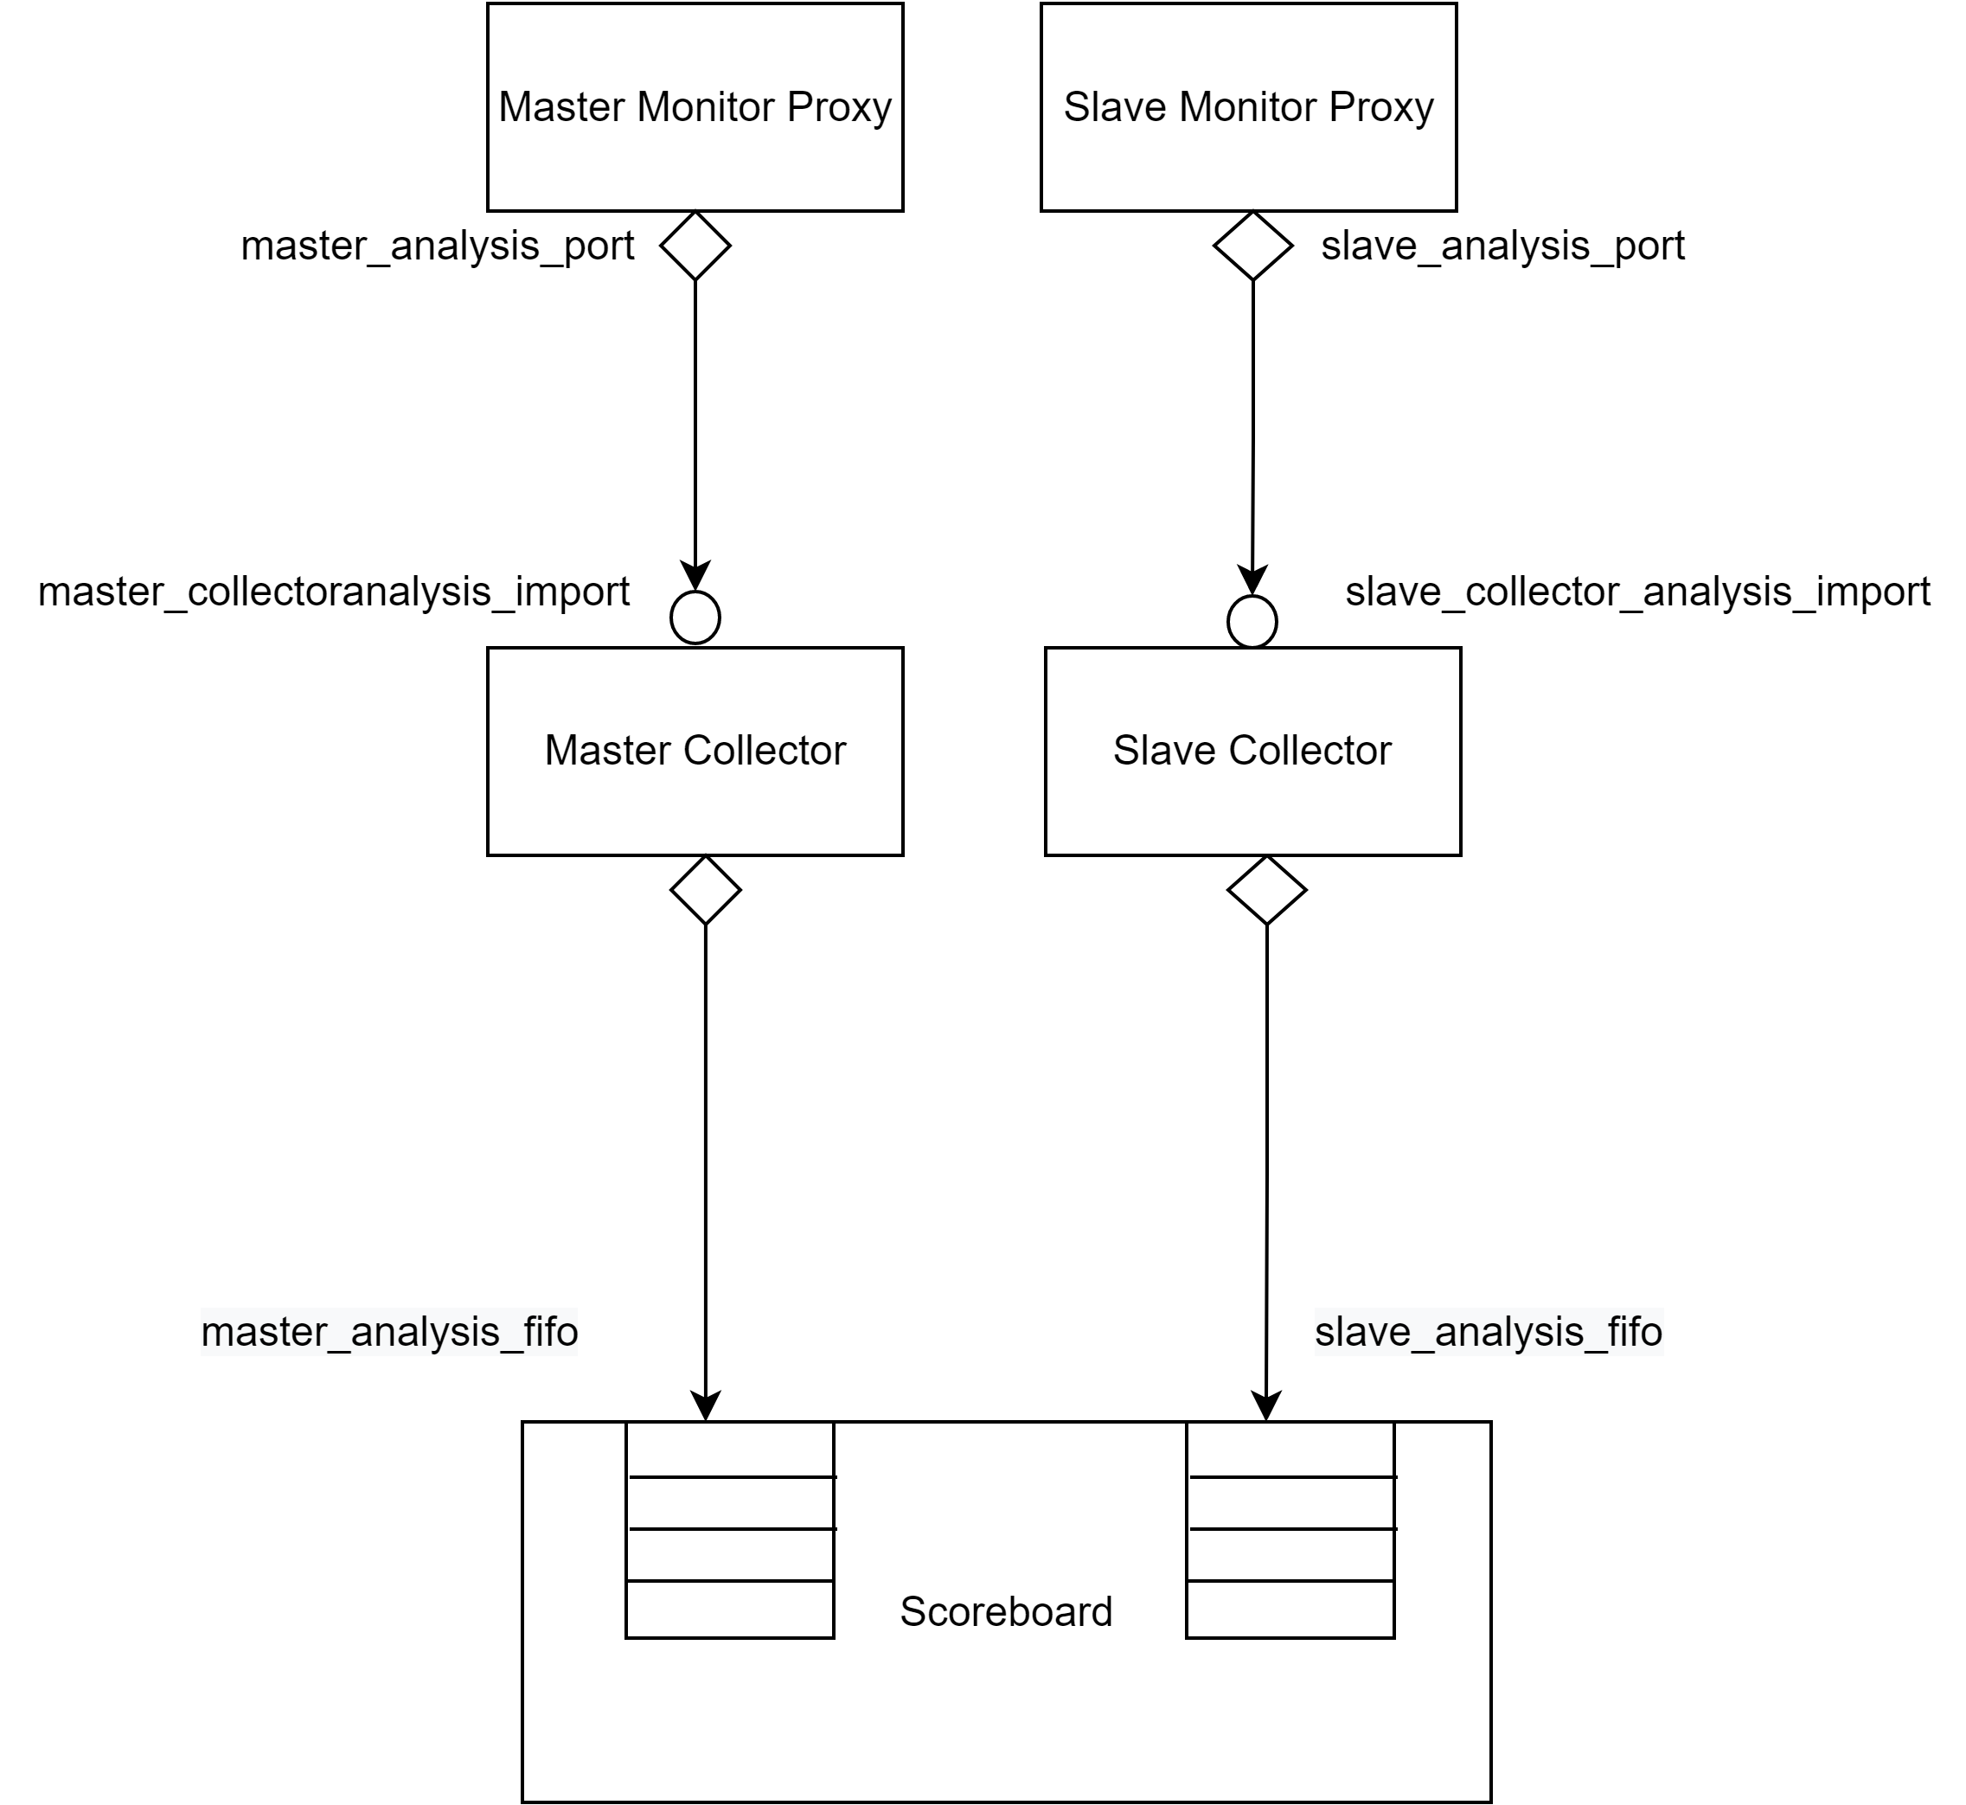](https://app.diagrams.net/?page-id=vjRAvNHTqynRuJHD0nhU&scale=auto&G1xGbOr5e7XSGVEygCZIAbO3XIP9cl_5ZO)

**Fig 3.8** connection of the analysis ports of the monitor to the scoreboard analysis fifo

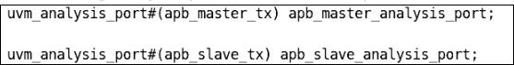In the monitor proxy class of master and slave, two analysis ports are declared. Fig 3.9 shows the declaration of master analysis port and slave analysis port in the master monitor proxy and slave monitor proxy.

**Fig 3.9** Declaration of slave and master analysis port in the slave and master monitor proxy

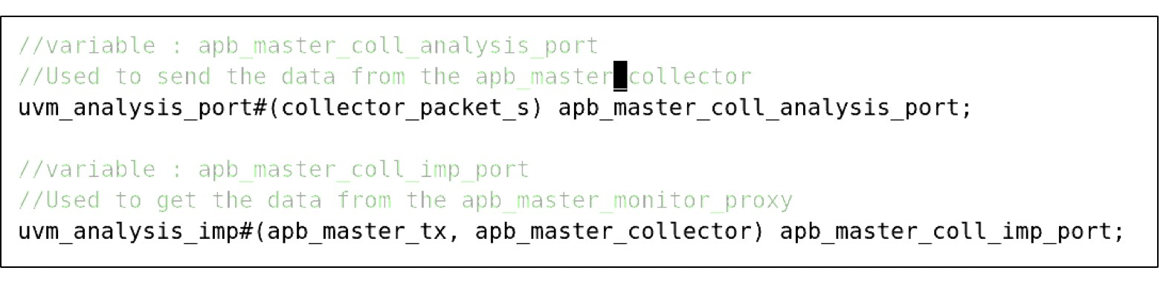

**Fig 3.10** Declaration of analysis port and import in the apb master collector

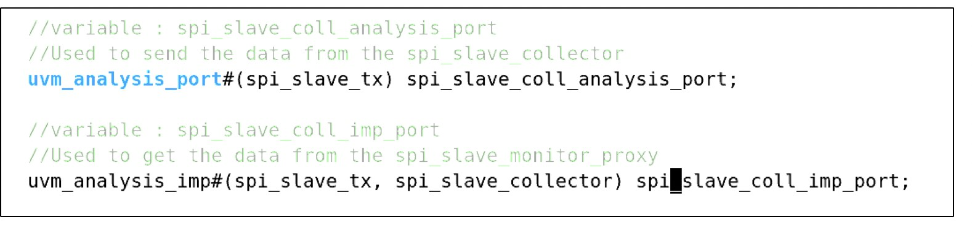

**Fig 3.11** Declaration of analysis port and import in the spi slave collector

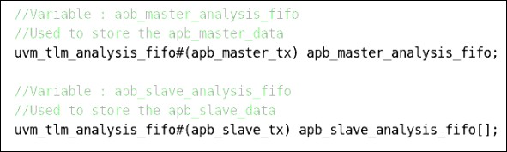In the scoreboard, two analysis fifo’s are declared. Fig 3.12 shows the declaration of master analysis fiifo and slave analysis fifo in the scoreboard.

**Fig 3.12** Declaration of master and slave analysis fifo in the scoreboard

In the constructor, create objects for the two declared analysis fifo’s. Fig 3.13 shows the creation of the master and slave analysis port.



**Fig 3.13** Creation of the master and slave analysis port

In connect phase of the environment class, the analysis port of both master and slave monitor proxy class is connected to the analysis export of the master and slave fifo in the scoreboard. Fig 3.14 shows the connection made between the monitor analysis port and the scoreboard fifo’s in the connect phase of the env class.



**Fig 3.14** Connection done between the analysis port and analysis fifo export in the env class

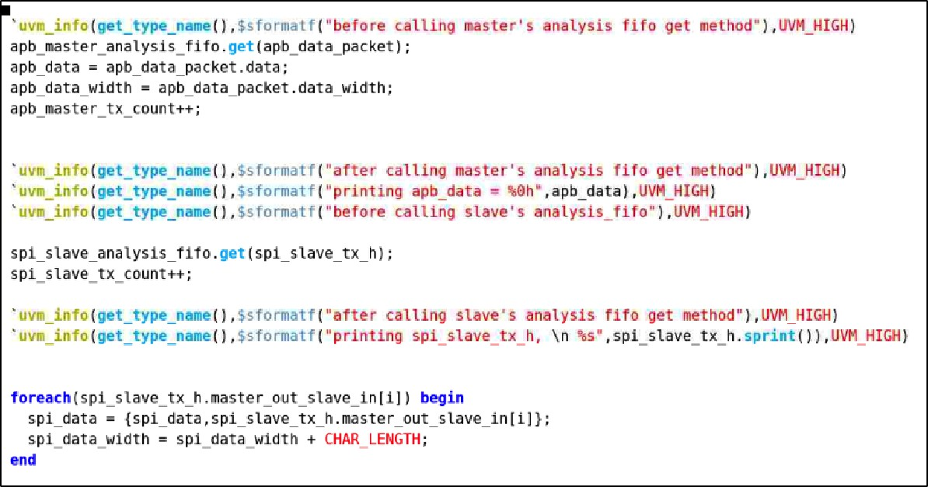In the run phase of the scoreboard, the get() method is used to get the data packet from the monitor write() method. Fig 3.15 shows the use of the get() method to get the transaction from the monitor analysis port.

**Fig 3.15** Use of get method to get the packet from monitor analysis port

The Comparison of the paddr, pwrite, pwdata and prdata from the master monitor and slave monitor is done in the run phase. Fig 3.16 shows the comparison of the master pwdata with slave pwdata.

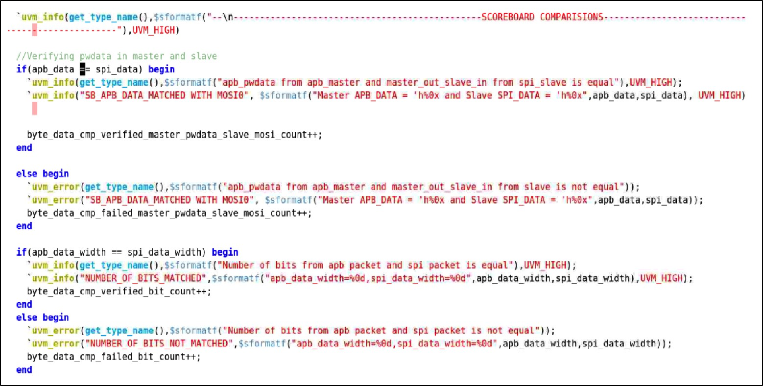

**Fig 3.16** The comparison of the master pwdata with slave pwdata

Similarly, the comparison is done for the signals as well.

Fig 3.17 explains the flow chart of the run phase in the scoreboard.

[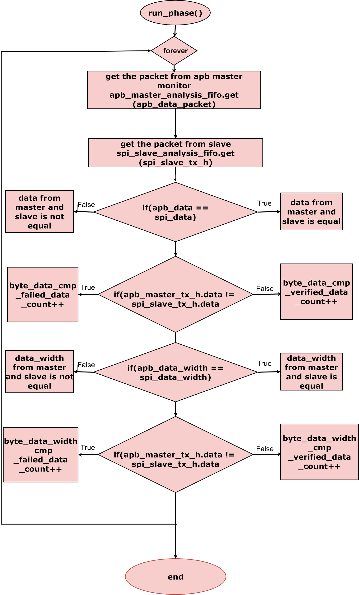](https://app.diagrams.net/?page-id=q5qjsr47D_Mab2Ly9yYy&scale=auto&G1KClO_4aTyeDaTuTjtaUuDRnuAELoOYTv)

**Fig 3.17** Flow chart of the scoreboard run phase

In the run phase, inside the forever loop, the scoreboard master analysis fifo gets the transaction from the master monitor analysis port using the get() method. Whenever the packet is received the transaction counter i.e, master_tx_count will be incremented.

[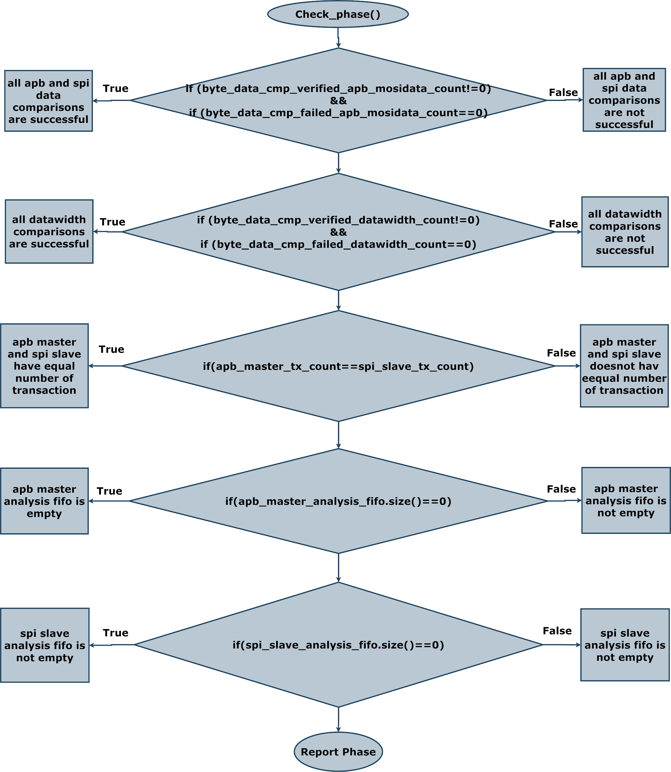](https://app.diagrams.net/?page-id=Q7W-q8eCcnEVNuaL7W8T&scale=auto&G13c4PZo9ShtcY7NVKNA-M4GdT2oXFaEl2)

**Fig 3.18** Flow chart of the scoreboard report phase

##### Pulpino SPI Master IP Verification Virtual Sequencer

In virtual sequencer , declaring the handles for environment_configuration, master_sequencer and slave_sequencer.

##### APB Master Agent

APB master agent component is a class extending from uvm_agent. It gets the apb master agent config handle and based on that we will create and connect the components. It creates the apb master sequencer and apb master driver only if the apb master agent is active which will depend on the value of is_active variable declared in the apb master agent configuration file. The apb master coverage is created in build_phase if the has_ coverage variable is 1 which is declared in the apb master agent configuration file. Please refer to figure 3.19 for the apb master agent build_phase code snippet.

APB master agent build phase has creation of,

1. apb master sequencer
2. apb master driver proxy
3. apb master monitor proxy
4. apb master coverage components.

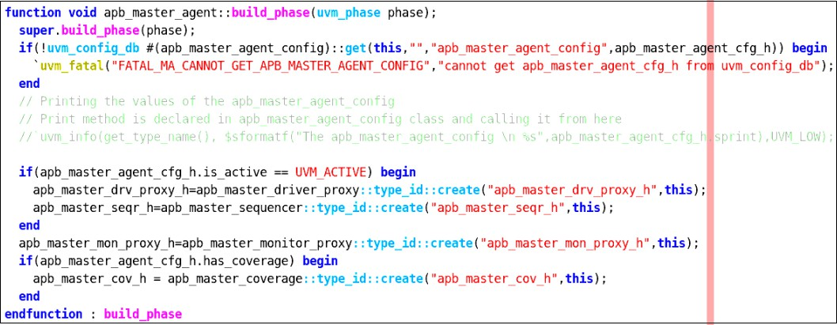

**Fig 3.19** APB master agent build phase code snippet

APB master agent configuration handles declared in the above created components will be mapped here in the connect phase. The apb master driver proxy and apb master sequencer are connected using TLM ports if the apb master agent is active. The apb master coverage’s analysis_export will be connected to apb master monitor proxy’s master_analysis_port in connect_phase.

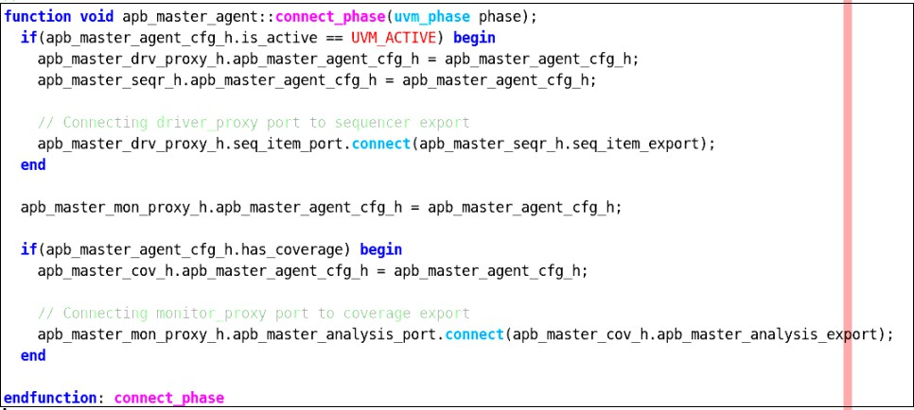

**Fig 3.20** APB master agent connect phase code snippet

##### APB Master Sequencer

APB master sequencer component is a parameterised class of type apb master transaction, extending uvm_sequencer. APB sequencer sends the data from the apb master sequences to the apb driver proxy.

##### APB Master Driver Proxy

APB master driver proxy component is a parameterised class of type apb master transaction, extending uvm_driver. It gets the apb master agent config handle and based on the configurations we will drive and sample the paddr, pselx, pwdata and prdata signals respectively. It gets the master transaction into the apb driver proxy using get_next_item() method.

As the apb driver bfm interface cannot access the class based apb master transaction data, so we have to convert that into struct data type. Similarly, it converts the apb master configuration values into struct data type. APB master driver proxy will call the converter class to convert the master transaction packet and master configuration packet into struct data packet and struct configuration packet respectively (declared in apb global package) and then will pass it to apb master driver bfm using drive_to_bfm method declared in apb master driver bfm. The drive to bfm method starts the drive_to_bfm (data_packet, configuration packet) which is declared in apb driver bfm.

[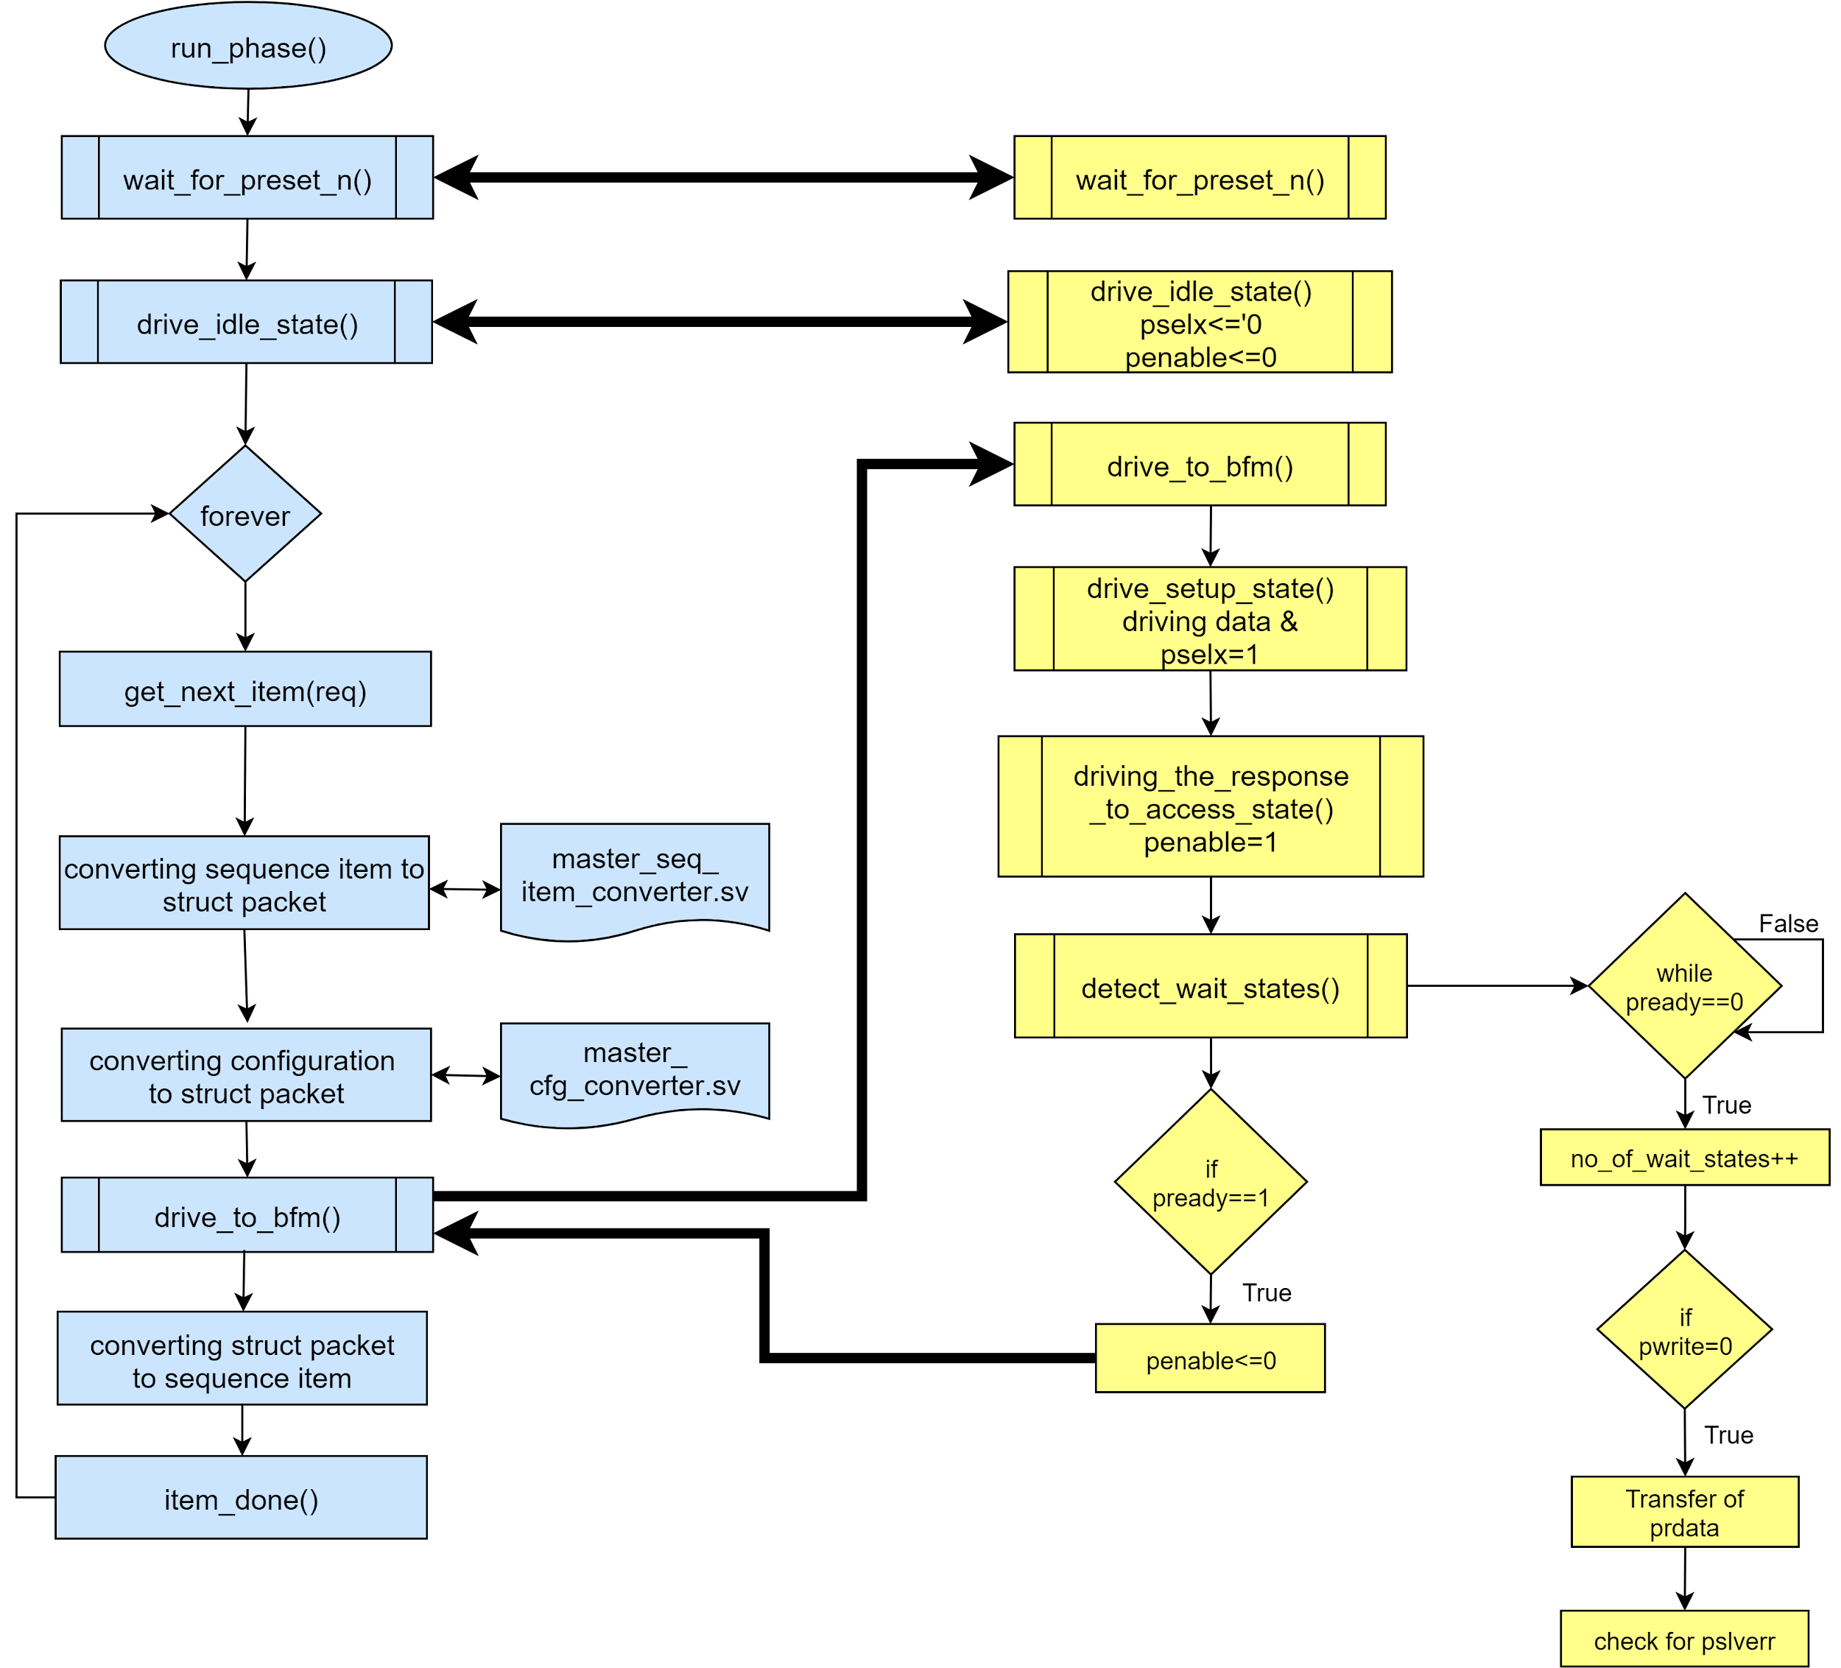](https://app.diagrams.net/?page-id=C5RBs43oDa-KdzZeNtuy&scale=auto&G1eDgEqjhFuv5kUoQO1FT8N5UviA8E6wbG)

**Fig 3.21** Flowchart of communication between apb master driver proxy and apb master driver bfm

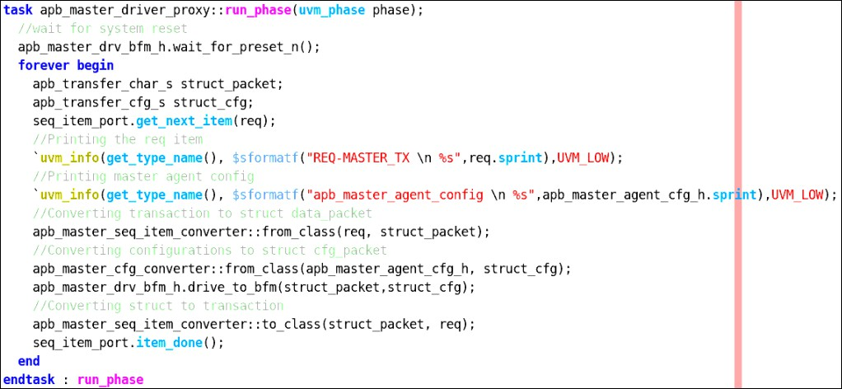

**Fig 3.22** run phase of apb master driver proxy code snippet

##### APB Master Monitor Proxy

APB master monitor proxy component is a class extending uvm_monitor. It gets the apb master agent config handle and based on the configurations we will sample the pwdata and prdata signals. It declares and creates the apb master analysis port to send the sampled data.

[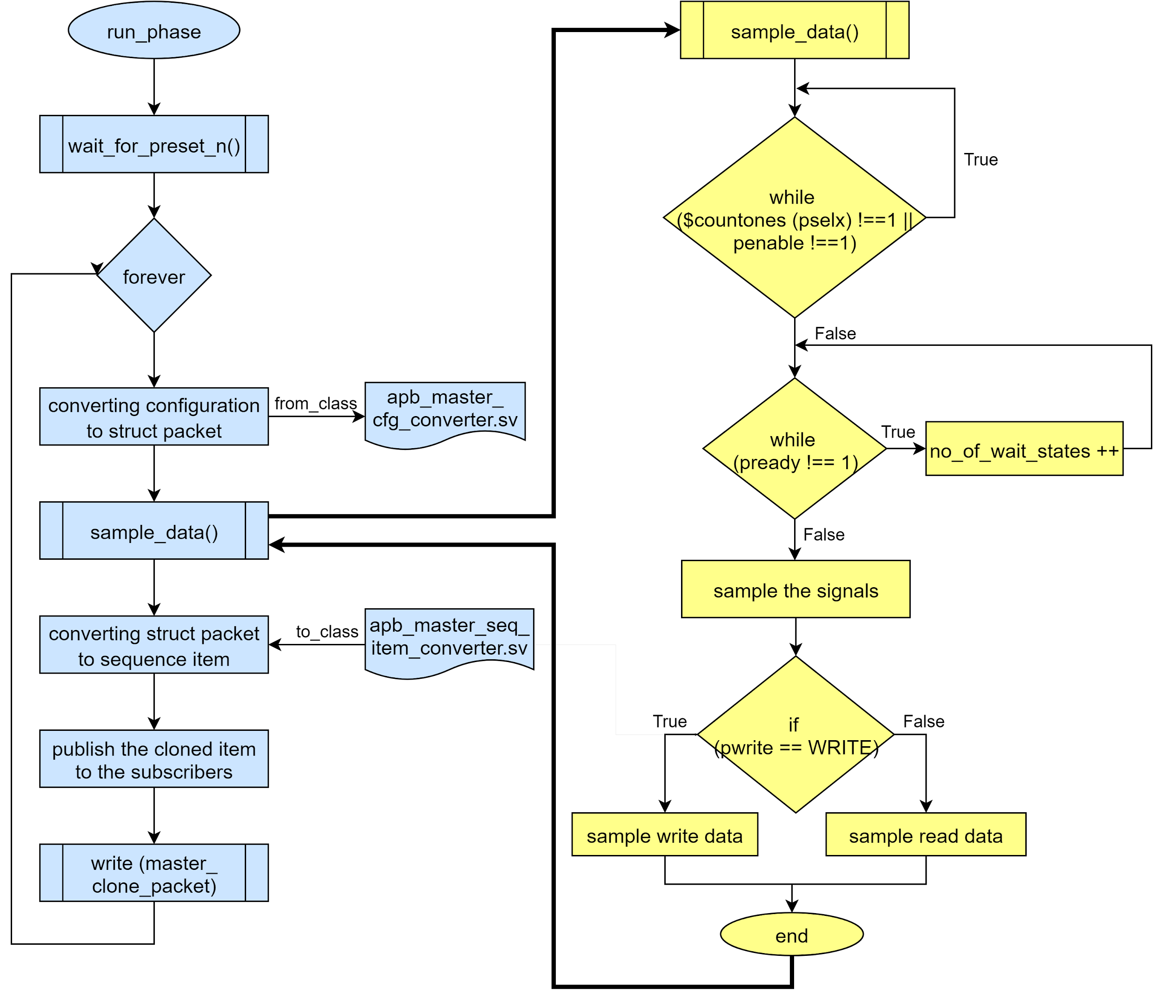](https://app.diagrams.net/?page-id=C5RBs43oDa-KdzZeNtuy&scale=auto&G1BhUXaFXHRKTd-S8HERCvB1a5f8mYnlzK)

**Fig 3.23** Flowchart of apb master monitor proxy and apb master monitor bfm communication

##### APB Master Adapter

APB master adapter is a class component that extends from uvm_reg_predictor. Its functionality is to convert the register_level_transactions to the apb bus_level_trasactions using bus2reg method. It is also used to convert the apb bus_level_transactions to the register_level_trasactions using reg2bus method.

##### SPI Slave Agent

Spi slave agent component is a class extending uvm_agent. It gets the spi slave agent configuration and based on that we will create and connect the components. It creates the spi

slave sequencer and spi slave driver only if the spi slave agent is active which will depend on the value of is_active variable declared in the spi slave agent configuration file. The spi slave coverage is created in build_phase if has_covergae variable is 1 which is declared in the spi slave agent configuration file. For more information about spi master agent configuration, please refer to [Chapter 5.3](https://docs.google.com/document/d/1YuunG7YxCosKsqsMkhnZfKwNt0CNl9lsqkHC52Uejpk/edit#heading%3Dh.l39yp4sdoec0)

Spi slave agent build phase has creation of,

1. spi slave sequencer
2. spi slave driver proxy
3. spi slave monitor proxy
4. spi slave coverage components.

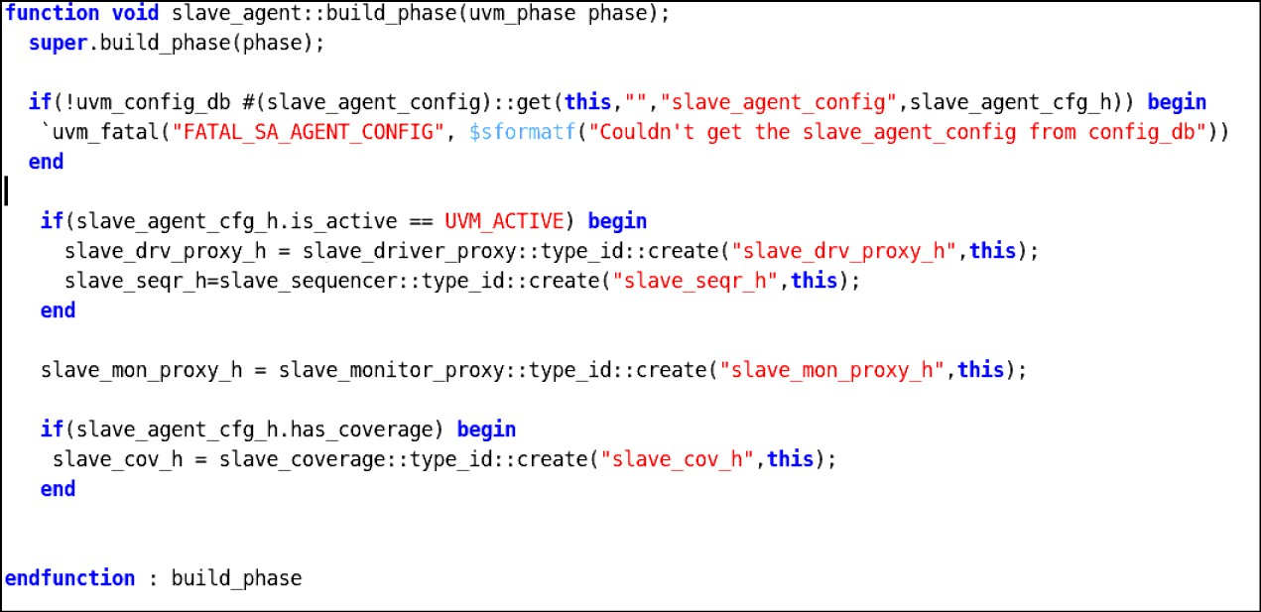

**Fig 3.24** Spi slave agent build phase code snippet

Spi slave agent configuration handles declared in the above created components will be mapped here in the connect phase. The spi slave driver proxy and spi slave sequencer is connected using tlm ports if the spi slave agent is active. The spi slave coverage’s analysis_export will be connected to spi slave monitor proxy’s slave_analysis_port in connect_phase.

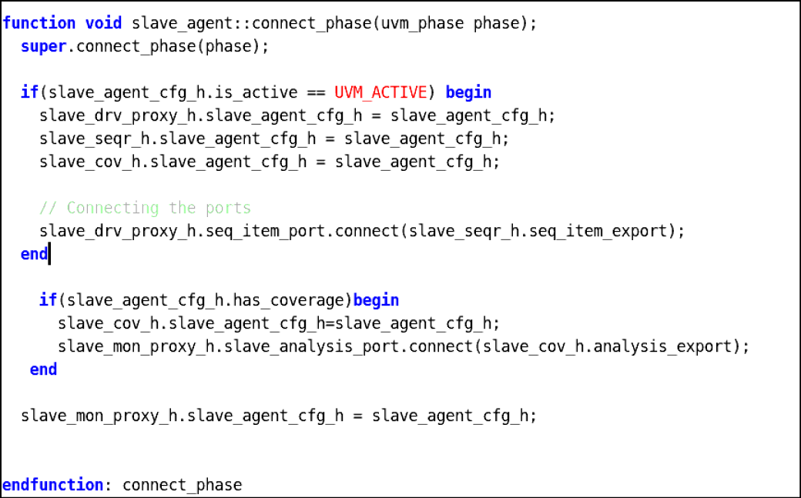

**Fig 3.25** Spi slave agent connect phase code snippet

##### SPI Slave Sequencer

Spi slave sequencer component is a parameterised class of type spi slave transaction, extending uvm_sequencer. Spi sequencer sends the data from the spi slave sequences to the spi driver proxy.

##### SPI Slave Driver Proxy

Spi slave driver proxy component is a parameterised class of type spi slave transaction, extending uvm_driver. It gets the spi slave agent config handle and based on the configurations we will drive and sample the mosi and miso signals respectively. It gets the slave transaction into the spi driver proxy using get_next_item() method.

As the spi driver bfm interface cannot access the class based spi slave transaction data, so we have to convert that into struct data type. Similarly, it converts the spi slave configuration values into struct data type. Spi slave driver proxy will call the converter class to convert the slave transaction packet and slave configuration packet into struct data packet and struct configuration packet respectively(declared in spi global package) and then will pass it to spi slave driver bfm using drive to bfm method declared in spi slave driver bfm. The drive to bfm method starts the drive_to_bfm (data_packet, configuration packet) which is declared in spi driver bfm.

[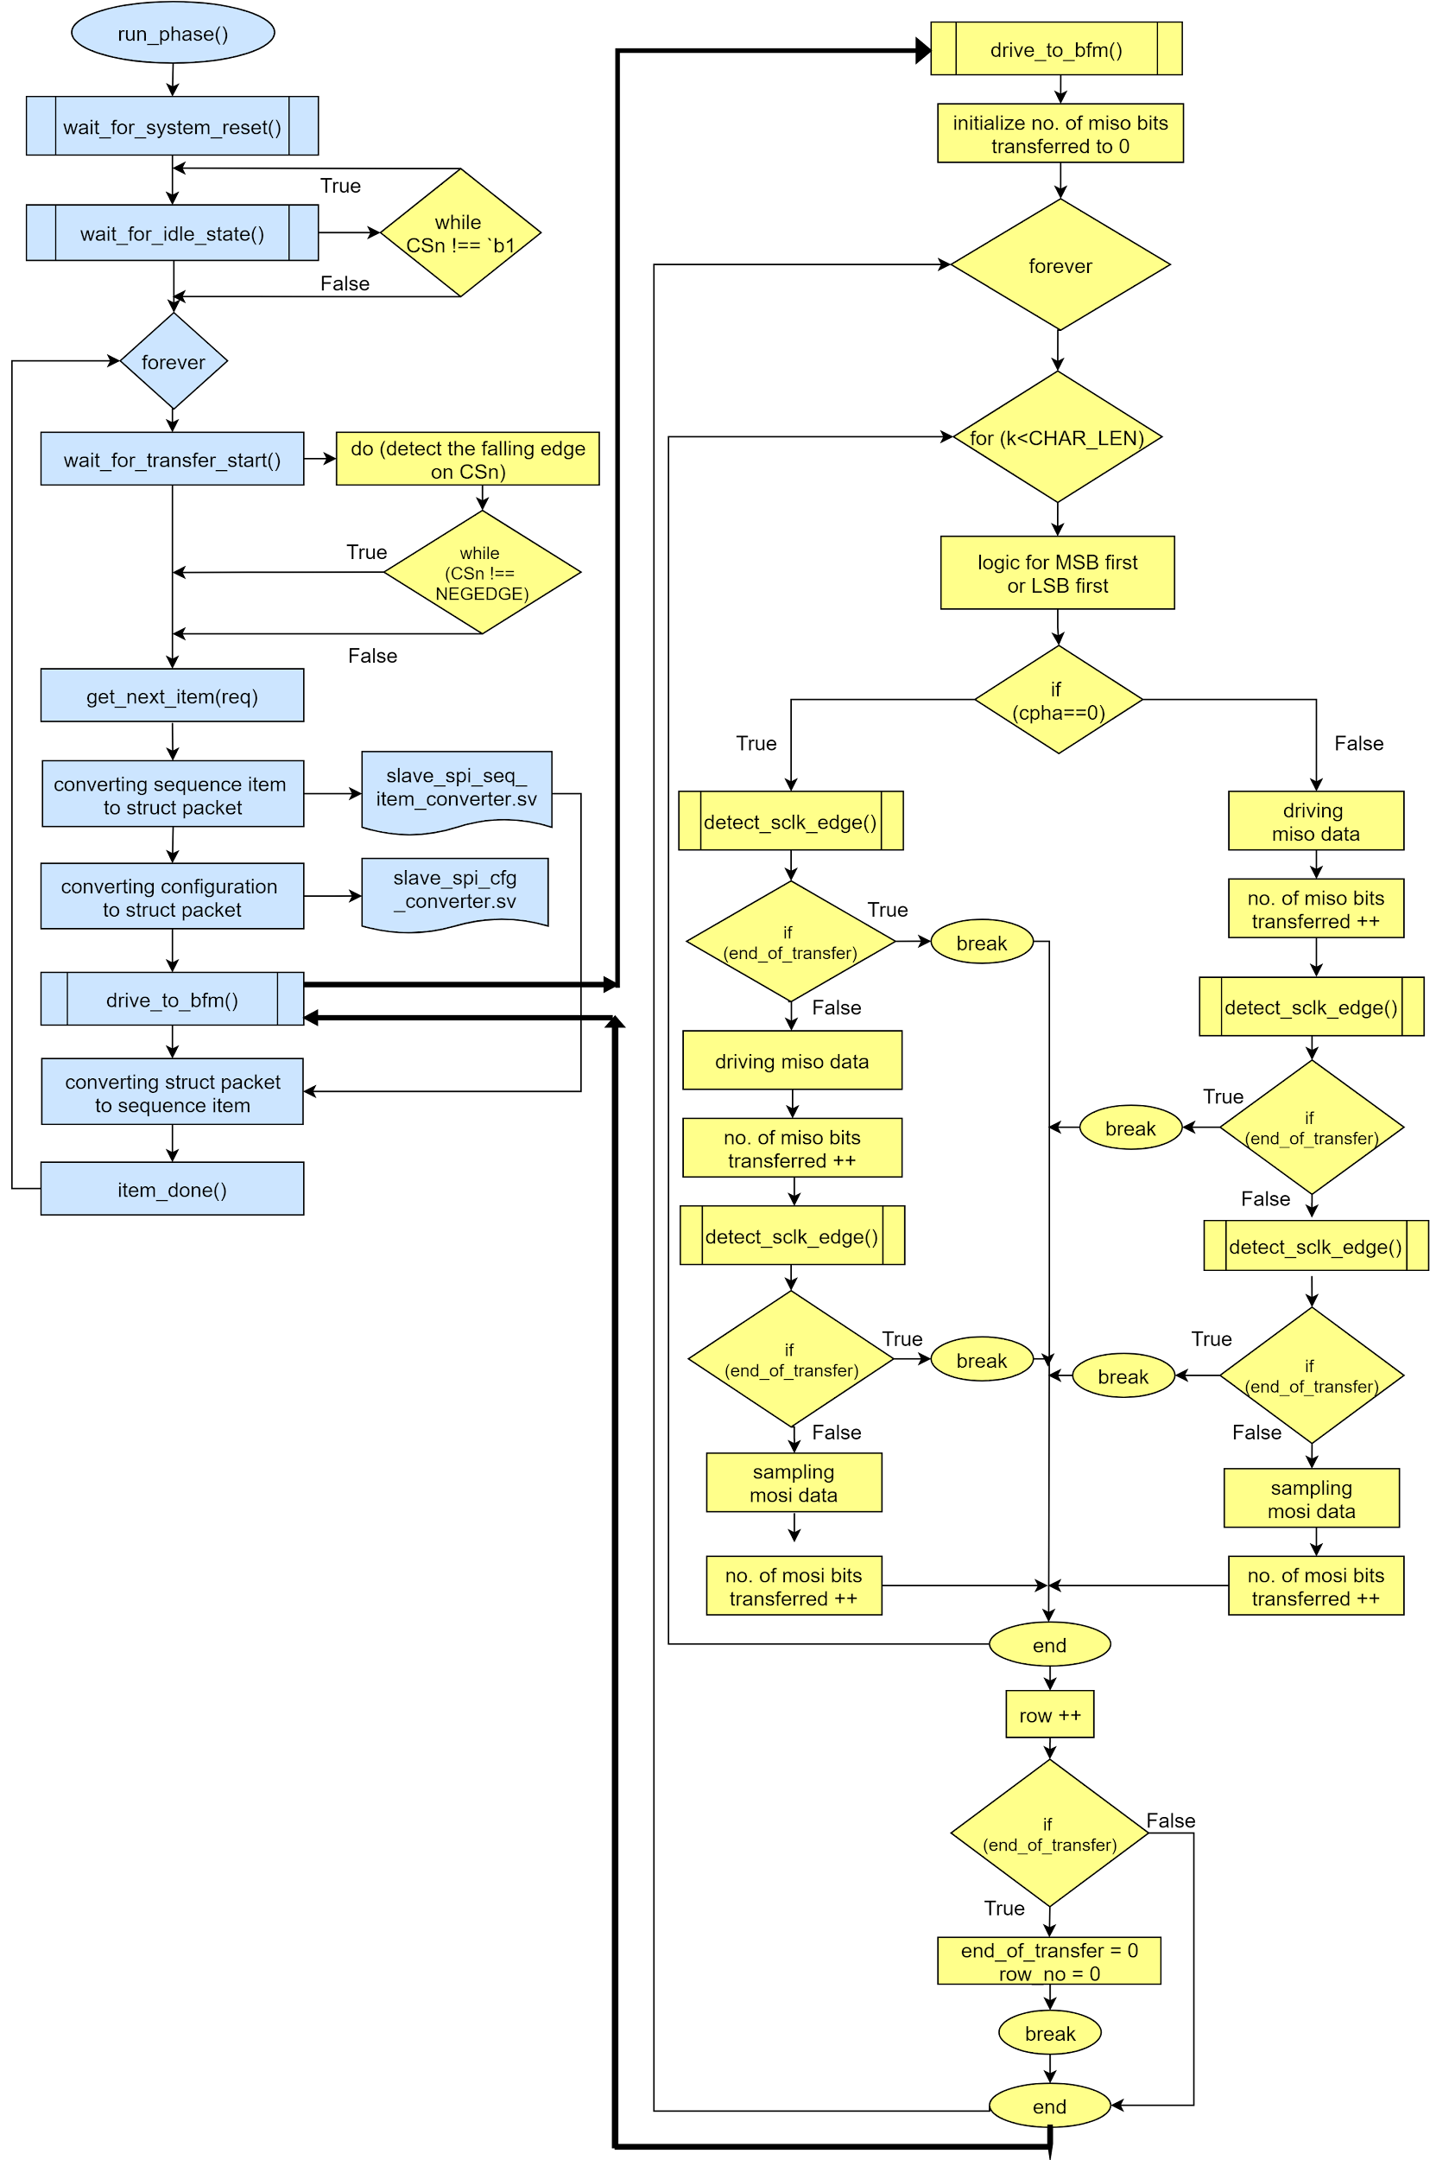](https://app.diagrams.net/?page-id=C5RBs43oDa-KdzZeNtuy&scale=auto&G1tL3E9-_g-F7ZSKSoe4RrG8M9HKNYekzG)

**Fig 3.26** Flowchart of spi slave driver bfm and slave driver proxy communication

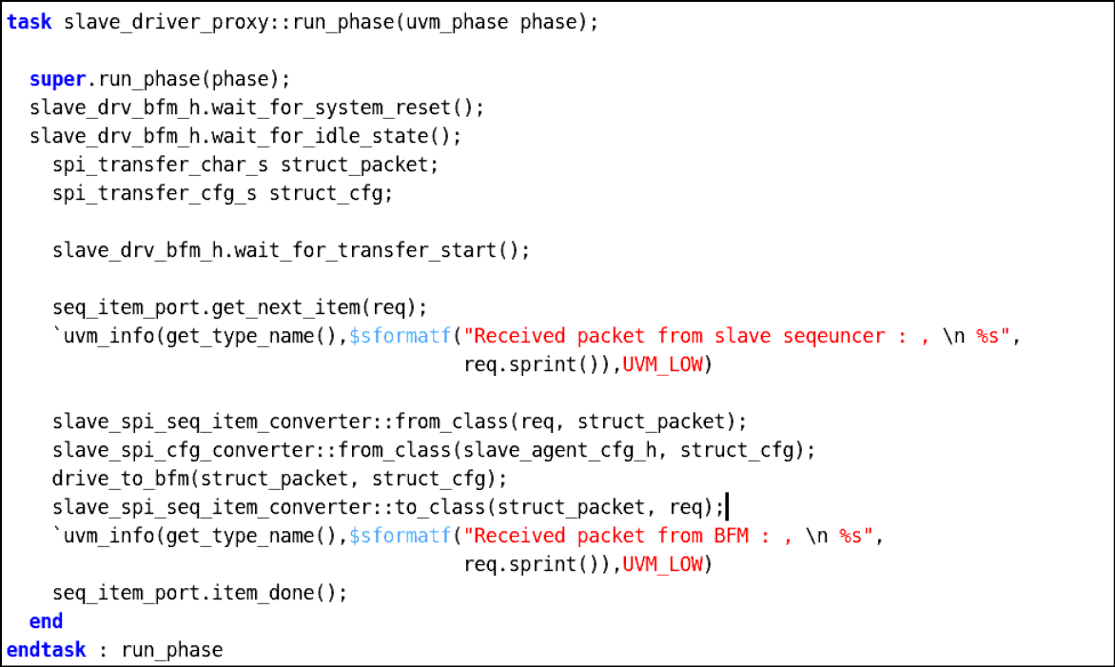

**Fig 3.27** Spi slave driver proxy build phase code snippet

##### SPI Slave Monitor Proxy

Spi slave monitor proxy component is a class extending uvm_monitor. It gets the spi slave agent config handle and based on the configurations we will sample the mosi and miso signals. It declares and creates the spi slave analysis port to send the sampled data. The spi slave monitor proxy will get the sampled data from spi master monitor bfm as shown in figure 3.28.

[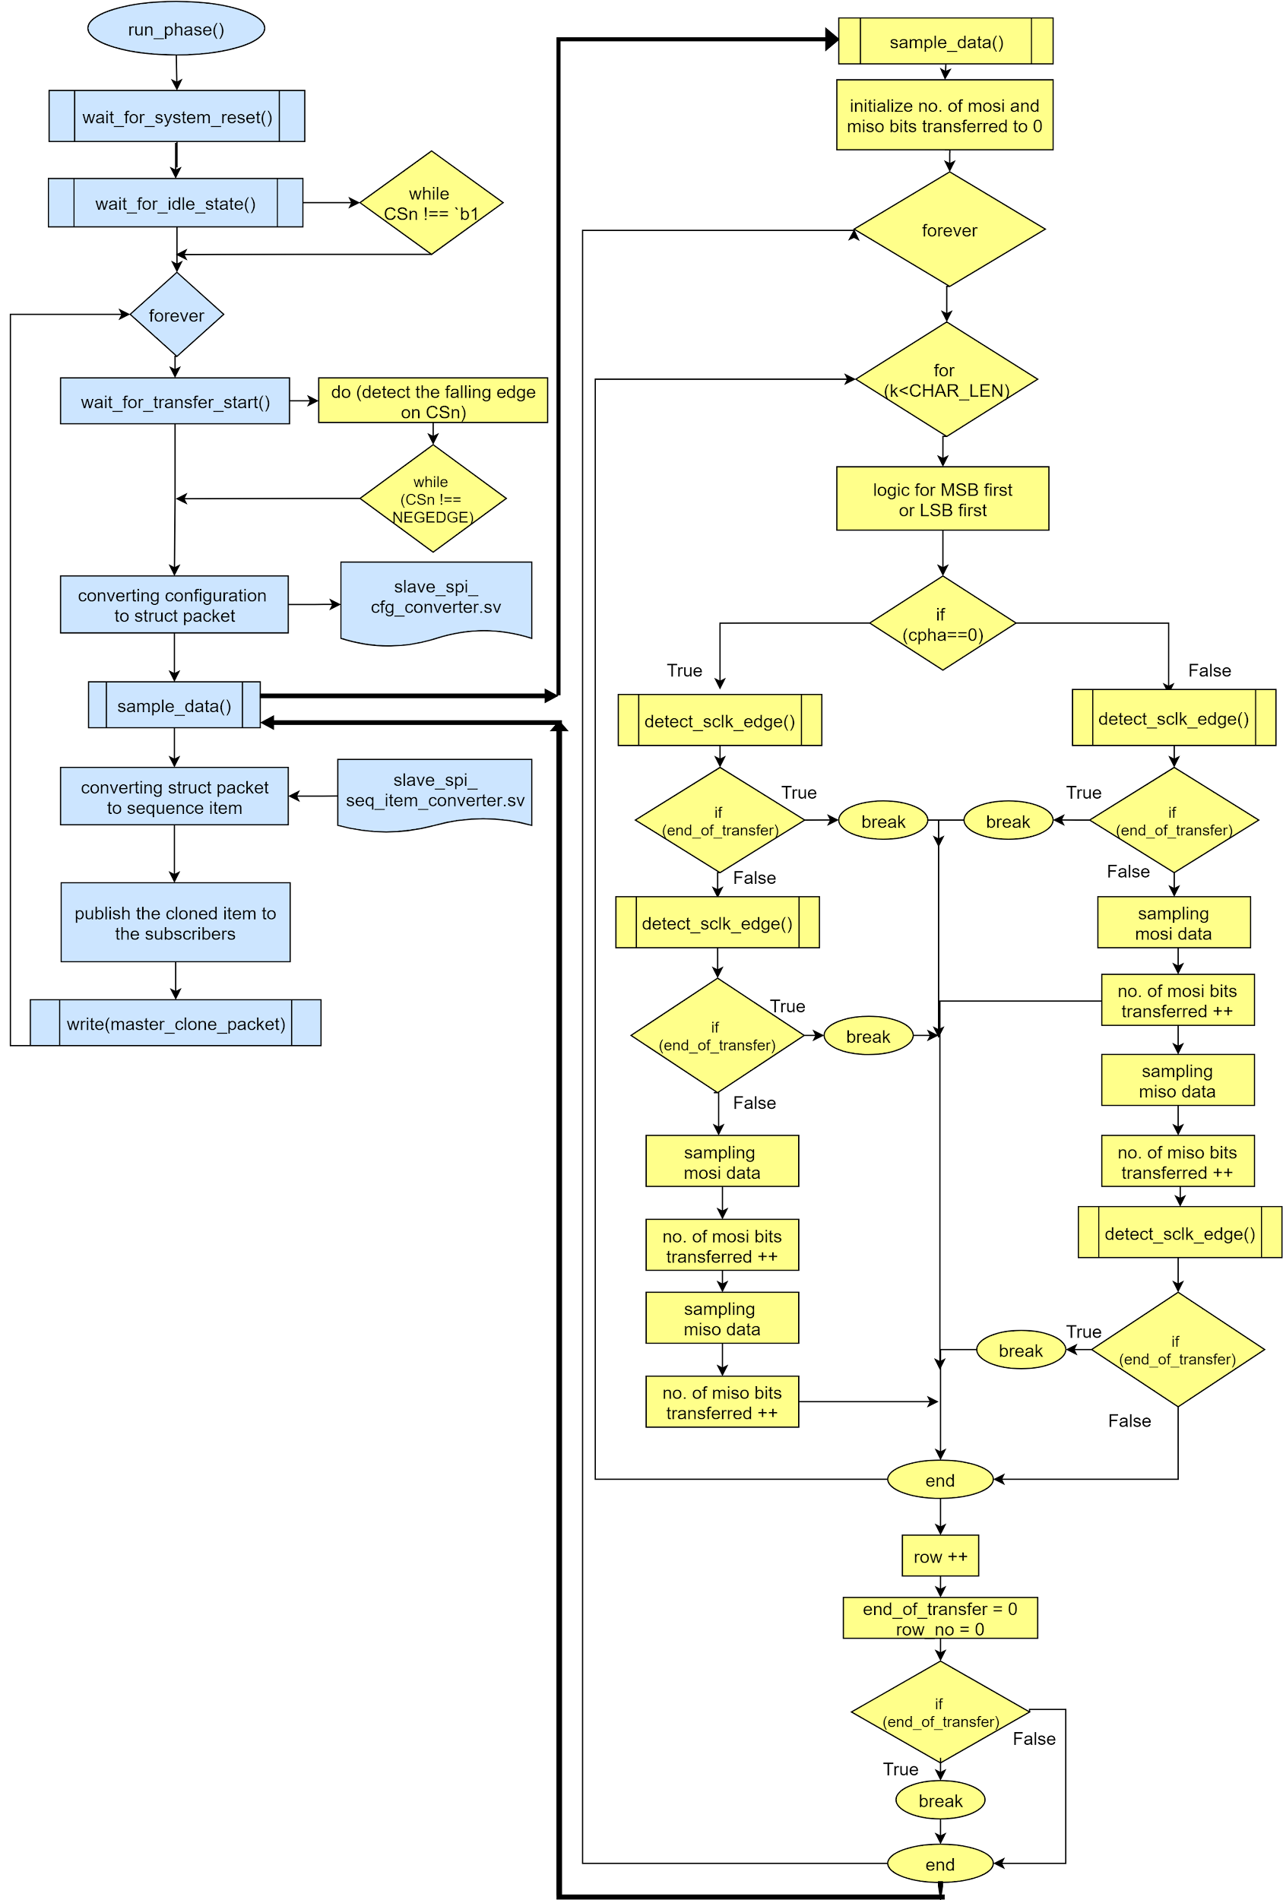](https://app.diagrams.net/?page-id=C5RBs43oDa-KdzZeNtuy&scale=auto&G12qwze9Z-Mc0y48XUDHSszCTXK_WzxVhp)

**Fig 3.28** Flowchart of spi slave monitor bfm and slave monitor proxy communication

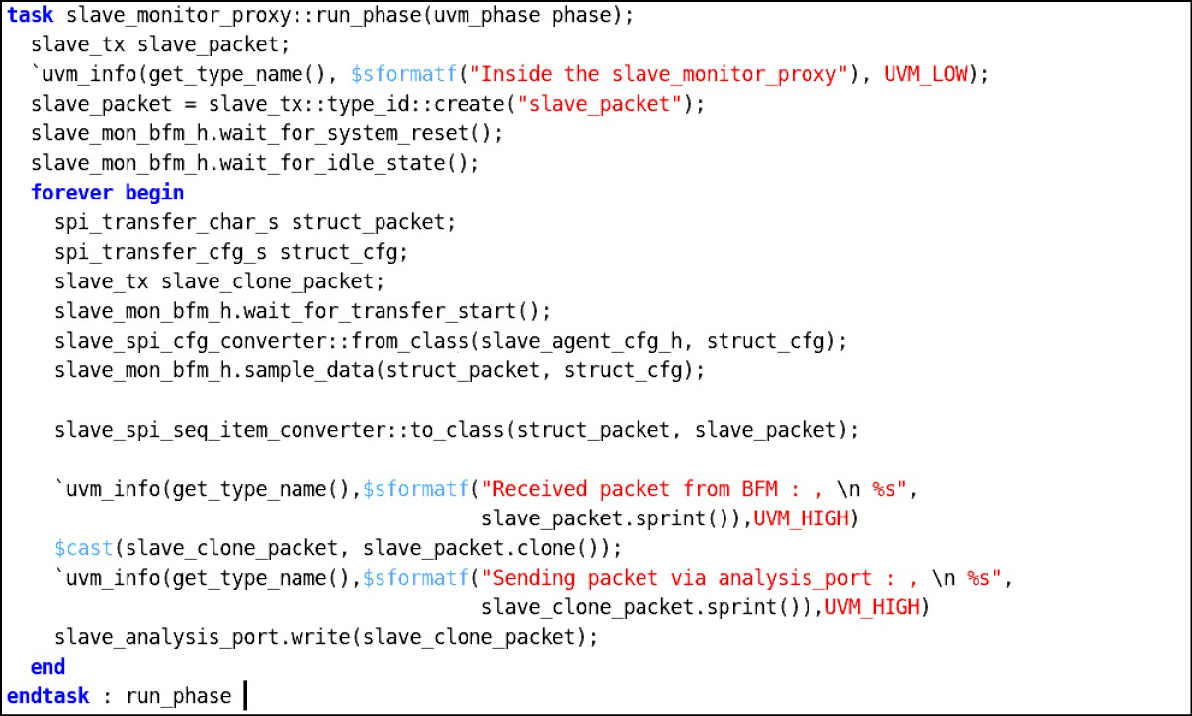

**Fig 3.29** Run phase of spi slave monitor proxy code snippet

##### SPI Slave Adapter

SPI slave adapter is a class component that extends from uvm_reg_predictor. Its functionality is to convert the register_level_transactions to the spi bus_level_trasactions using bus2reg method. It is also used to convert the spi bus_level_transactions to the register_level_trasactions using reg2bus method.

##### UVM Verbosity

There are predefined UVM verbosity settings built into UVM (and OVM). These settings are included in the UVM src/uvm_object_globals.svh file and the settings are part of the enumerated uvm_verbosity type definition. The settings actually have integer values that increment by 100 as shown below table

Table 3.3 UVM verbosity Priorities

|  |  |
| --- | --- |
| **Verbosity** | **Default Value** |
| UVM_NONE | 0(Highest Priority) |
| UVM_LOW | 100 |
| UVM_MEDIUM | 200 |
| UVM_HIGH | 300 |
| UVM_FULL | 400 |
| UVM_DEBUG | 500(Lowest Priority) |

By default, when running a UVM simulation, all messages with verbosity settings of UVM_MEDIUM or lower (UVM_MEDIUM, UVM_LOW and UVM_NONE) will print. Table 3.3 shows the Verbosity levels that have used in this particular project

Table 3.4 Descriptions of each Verbosity level

|  |  |
| --- | --- |
| **Verbosity** | **Description** |
| UVM_NONE | UVM_NONE is level 0 and should be used to reduce report verbosity to a bare minimum of vital simulation regression suite messages. |
| UVM_LOW | UVM_LOW is level 100 and should be used to reduce report verbosity and only shows important messages |
| UVM_MEDIUM | UVM_MEDIUM is level 200 and should be used as the default $display command. If the verbosity isn’t selected then, these messages will print by default as UVM_MEDIUM. This verbosity setting should not be used for any debugging messages or for standard test-passing messages. |
| UVM_HIGH | UVM_HIGH is level 300 and should be used to increase report verbosity by showing both failing and passing transaction information, but does not show annoying UVM phase status information after it has been established that the UVM phases are working properly |
| UVM_FULL | UVM_FULL is level 400 and should be used to increase report verbosity by showing UVM phase status information as well as both failing and passing transaction information. |

### Chapter 4

# Directory Structure

#### Package Content

The package structure diagram navigates users to find out the file locations, where it is located and which folder.

[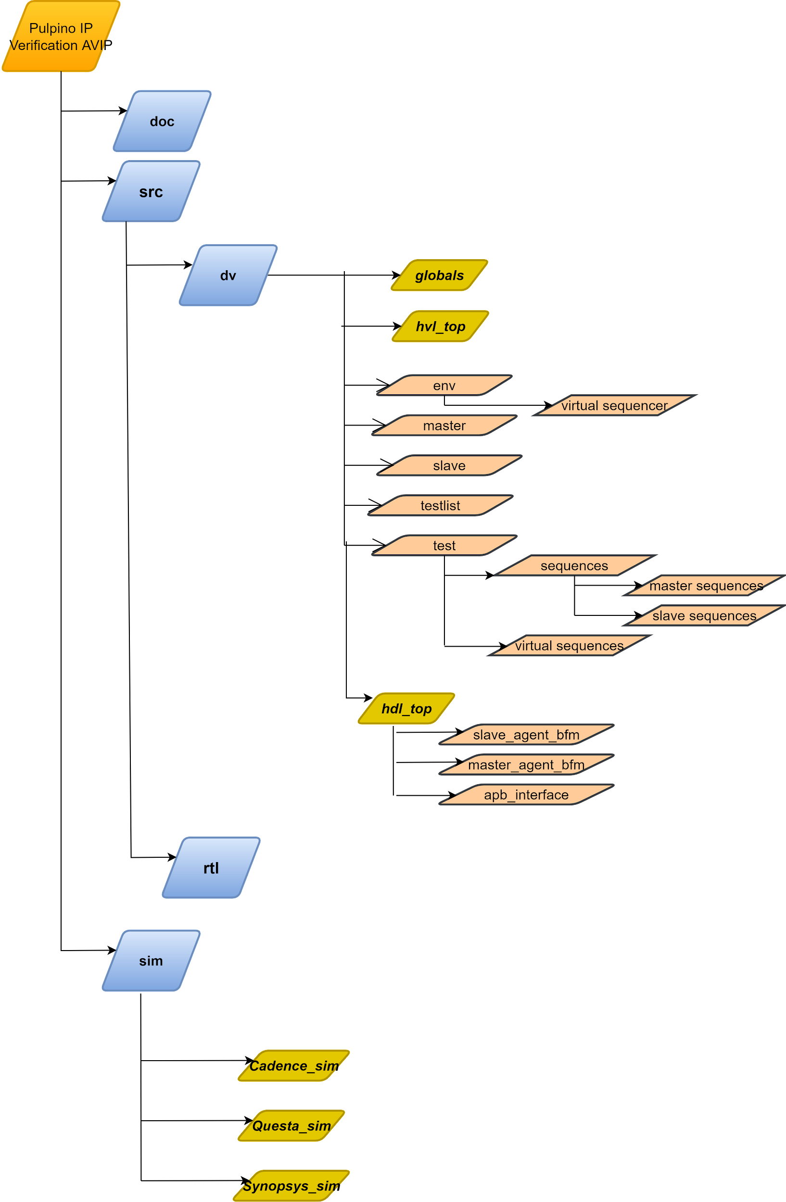](https://app.diagrams.net/?page-id=U7hxdUV7xR93_OYv5nGh&scale=auto&G1bKQCgKKWOddmec_I89lNbXHRUGI3eb6B)

**Fig 4.1** Package Structure of Pulpino_SPI_Master_IP_AVIP

Table 4.1 Directory Path

|  |  |
| --- | --- |
| **Directory** | **Description** |
| apb_avip/doc | Contains test bench architecture and components description and verification plan and assertion plan |
| apb_avip/sim | Contains all simulating tools and apb_compile.f file which contain all directories and compiling files |
| apb_avip/src/globals | Contains global package parameters(names,modes) |
| apb_avip/src/hvl_top | Contain all tb component folder(master,env,slave,test) |
| apb_avip/src/hdl_top | Contain all bfm files and assertions files |
| apb_avip/src/hdl_top/master_agent_bfm | Contain master agent, driver and monitor bfm files |
| apb_avip/src/hdl_top/slave_agent_bfm | Contains slave agent, driver and monitor bfm files |
| apb_avip/src/hdl_top/APB_interface | Contain apb interface file |
| apb_avip/src/hvl_top/test | Contains all test cases files |
| apb_avip/src/hvl_top/test/sequences/master_sequences | Contain all master sequence test files |
| apb_avip/src/hvl_top/test/sequences/slave_sequences | Contain all slave sequence test files |
| apb_avip/src/hvl_top/test/sequences/virtual_sequences | Contain all virtual sequence test files |
| apb_avip/src/hvl_top/env | Contain env config files and score board file |
| apb_avip/src/hvl_top/env/virtual_sequencer | Contain virtual sequencer file |
| apb_avip/src/hvl_top/master | Contain master agent files , coverage file |
| apb_avip/src/hvl_top/slave | Contain slave agent files , coverage file |

### Chapter 5

# Configuration

#### Global package variables

##### APB Global Package Variables

Table 5.1 APB Global package variables

|  |  |  |
| --- | --- | --- |
| **Name** | **Type** | **Description** |
| NO_OF_SLAVES | integer | specifies no of slaves connected to the APB interface |
| APB_transfer_char_s | struct | Structure to hold the packet data. |
| APB_transfer_cfg_s | struct | Structure to hold the configuration data. |
| apb_fsm_state_e | enum | Represents the type of state IDLE  SETUP ACCESS |
| slave_no_e | enum | Used to select the one slave at a time by one hot encoding SLAVE_0 = 16'b0000_0000_0000_0001 SLAVE_1 = 16'b0000_0000_0000_0010 SLAVE_2 = 16'b0000_0000_0000_0100 SLAVE_3 = 16'b0000_0000_0000_1000 SLAVE_4 = 16'b0000_0000_0001_0000 SLAVE_5 = 16'b0000_0000_0010_0000 |
| endian_e | enum | LITTLE_ENDIAN=1’b0 : lsb bit will store in first address location BIG_ENDIAN = 1’b1 : msb bit will store in first address location |
| tx_type_e | enum | WRITE=1’b1 : write transfer happen READ=1’b0 : read transfer happen |
| protectiontype_e | enum | Used to represent the protection type for transaction NORMAL_SECURE_DATA = 3'b000 NORMAL_SECURE_INSTRUCTION = 3'b001 NORMAL_NONSECURE_DATA = 3'b010 NORMAL_NONSECURE_INSTRUCTION = 3'b011 PRIVILEGED_SECURE_DATA = 3'b100 PRIVILEGED_SECURE_INSTRUCTION = 3'b101 |
| slave_error_e | enum | Represents slave error signal NO_ERROR=1’b0; ERROR=1’b1; |

##### SPI Global Package Variables

Table 5.2 SPI Global package variables

|  |  |  |
| --- | --- | --- |
| **Name** | **Type** | **Description** |
| NO_OF_SLAVES | integer | specifies no of slaves connected to the spi interface |

|  |  |  |
| --- | --- | --- |
| CHAR_LENGTH | integer | specifies the length of the transfer |
| MAXIMUM_BITS | integer | It’s maximum bits supported per transfer |
| NO_OF_ROWS | integer | specifies total no of 8 bits data packets |
| edge_detect_e | enum | **POSEDGE =2’b01** : posedge on the signal, the transition from 0->1  **NEGEDGE =2’b10** : negedge on the signal, the transition from 1->0 |
| shift_direction_e | enum | **LSB_FIRST =1’b0** : lsb will be shifted first  **MSB_FIRST =1’b1** : msb will be shifted first. |

##### Pulpino SPI Master IP Global Package Variables

It has the struct packet to store the APB Collector packet data.

#### Configuration used

* + - 1. Env configuration
      2. Master Agent configuration
      3. Slave Agent configuration

#### Master agent configuration

Table 5.3 APB Master_agent_config

|  |  |  |  |
| --- | --- | --- | --- |
| **Name** | **Type** | **Default value** | **Description** |
| is_active | enum | UVM_ACTIVE | It will be used for configuring an agent as an active agent means it has sequencer, driver and monitor or passive agent which has monitor only. |
| no_of**_**slaves | integer | ‘d1 | Used for specifying the number of slaves connected to the master |
| has_coverage | integer | ‘d1 | Used for enabling the master agent coverage |

#### Slave agent configuration

Table 5.4 SPI Slave_agent_config

|  |  |  |  |
| --- | --- | --- | --- |
| **Name** | **Type** | **Default value** | **Description** |
| is_active | enum | UVM_ACTIVE | It will be used for configuring agent as an active agent means it has sequencer,driver and monitor and if it’s a passive agent then it will have only monitor |
| slave _id | integer | ‘d0 | Used for indicating the ID of this slave e.g. slave 0 is selected. |

|  |  |  |  |
| --- | --- | --- | --- |
| spi_modes | enum | CPOL0_CPHA0 | Used for setting the operation modes. (refer Table 5.3 for explanation) |

#### Environment configuration

Table 5.5 Env_config

|  |  |  |  |
| --- | --- | --- | --- |
| **Name** | **Type** | **Default value** | **Description** |
| has_scoreboard | integer | 1 | Enables the scoreboard,it usually receives the transaction level objects via TLM ANALYSIS PORT. |
| has_virtual_sqr | integer | 1 | Enables the virtual sequencer which has master and slave sequencer |
| no_of_slaves | integer | ‘h1 | Number of slaves connected to the APB interface |
| spi_master_reg_ block | spi_maste r_apb_if | null | Registers block handle for spi master module |

### Chapter 6

# Verification Plan

#### Verification plan

Verification plan is an important step in Verification flow; it defines the plan of an entire project and verifies the different scenarios to achieve the test plan.

A Verification plan defines what needs to be verified in Design under test(DUT) and then drives the verification strategy. As an example, the verification plan may define the features that a system has and these may get translated into the coverage metrics that are set.

**Refer the below link for Pulpino Specifications:** [**Pulpino IP Verification Specifications**](https://pulp-platform.org/docs/pulpino_datasheet.pdf)

#### Registers used in Pulpino

1. Status Register
2. Clock Divider
3. SPI Command
4. SPI Address
5. SPI Length
6. Dummy Cycles
7. Tx FIFO
8. Rx FIFO
9. Interrupt Configurations

#### Features Supported:

##### Reset

1. Hard Reset
2. Soft Reset

##### Spi Modes for Writes and Reads

1. Standard Mode
2. Quad Mode

##### Clock Divider

1. Even CLKDIV (2)
2. Odd CLKDIV (1, 3)

##### SPI Transfer Length

1. Zero_Command - Zero_Address - Non_Zero_Data(8x)
2. Zero_Command - Non_Zero_Address - Non_Zero_Data(8x)
3. Non_Zero_Command - Non_Zero_Address - Non_Zero_Data(8x)

##### SPI Dummy Cycles

* 1. For Writes

1. DUMMYWR_Zero_Clk_Cycles
2. DUMMYWR_Two_Clk_Cycles
   1. For Reads
3. DUMMYRD_Zero_Clk_Cycles
4. DUMMYRD_Two_Clk_Cycles

##### Interrupt Configuration

1. Threshold Configurations
   1. THTX
   2. RHTX
2. Counter Configuration
   1. CNTTX
   2. CNTRX
3. Enable
   1. EN=1
   2. EN=0
4. **Tx & Rx FIFO**

#### Template of Verification Plan

**Verification Plan Link:** [**Pulpino IP Verification vplan**](https://docs.google.com/spreadsheets/d/e/2PACX-1vRv4pFDuovxJrjZQiFEk60aXKkH_BK1IKLXgs3FFsK0-b6lyCz3_hKXMoCryYDTO572pqaBVseIqqVy/pubhtml)In the below Figure

**Section A** shows the S.No

**Section B** shows the Sections

**Section C** shows the Features

**Section D** shows the Description

**Section E & F** shows the Test cases names

**Section G** shows the Status of the test cases

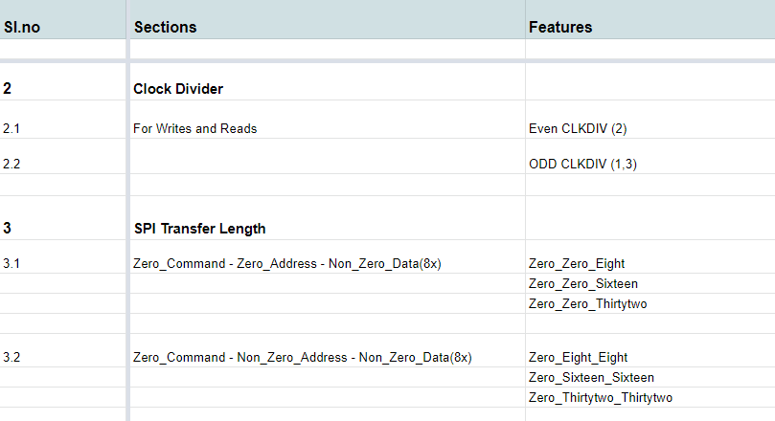

Fig 6.4.1

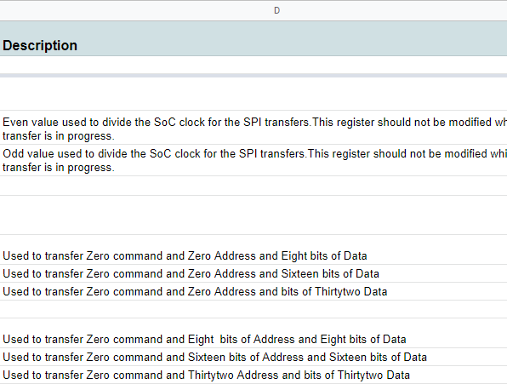

Fig 6.4.2

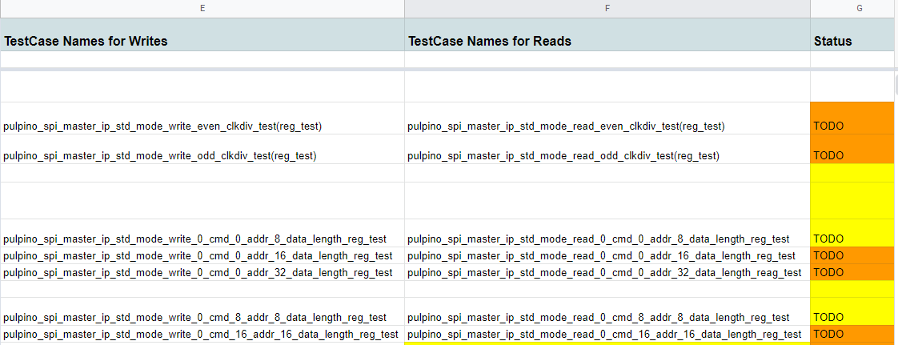

Fig 6.4.3

#### Sections for different test scenarios

Creating the different Sections for different test cases to be developed in the point of implementing the test scenarios

##### Directed test cases

These directed tests provide explicit stimulus to the design inputs, run the design in simulation, and check the behaviour of the design against expected results.

##### Directed test names

**Table no: 6.1**

|  |  |  |  |
| --- | --- | --- | --- |
| **Sl.No** | **Feature** | **Testname** | **Description** |
| 1 | SPI Modes | pulpino_spi_master_ip_basic_write  _test | Checks the mode of operation SPI is working |
| 2 | CLKDIV | pulpino_spi_master_ip_std_mode_r ead_even_clkdiv_test | Checks the Clock divisor for the System clock |
| 3 | SPI Length | pulpino_spi_master_ip_std_mode_ write_8_cmd_16_addr_32_data_len gth_test | Checks the command length and address length and data length to transfer |
| 4 | SPI Dummy | pulpino_spi_master_ip_std_mode_ write_8_dummy_write_test | Adds the Dummy cycles for the writes after address and command sent |
| 5 | Interrupt Configuration | pulpino_spi_master_ip_std_mode_ write_thtx_rhtx_cnttx_cntrx_value_ 2_test | Adds the threshold value and counter value for transmitter and receiver and enables the interrupts. |

##### Random test cases

Though a random test case is powerful in terms of finding bugs faster than the directed one, usually we prefer random test cases for the module and sub-system level verification and mostly we prefer directed test cases for the SoC level verification. .

Purely random test generations are not very useful because of the following two reasons-

* + - 1. Generated scenarios may violate the assumptions, under which the design was constructed
      2. Many of the scenarios may not be interesting, thus wasting valuable simulation time, hence random stimulus with the constraints..

##### Random test names

This test describes the randomization of modes and clock divider and transfer lengths and dummy cycles

**Table no: 6.1**

|  |  |  |  |
| --- | --- | --- | --- |
| **Sl.No** | **Feature** | **Testname** | **Description** |
| 1 | SPI modes, CLKDIV, SPI  Length, Dummy Cycles, Tx fifo, and Interrupts | pulpino_spi_master_ip_r and_reg_test | Randomises the Spi modes and transfer lengths and clock divider value and dummy cycles for writes and reads and interrupt values for setting up threshold values for transmitter and Receiver |

##### Cross test cases

The Cross test describes the creation of specific test cases required to hit the crosses and cover points defined in the functional coverage and running them with multiple seeds with functional coverage.

##### Cross test names

This test describes the Cross test between the spi modes and CLKDIV and transfer length and dummy cycles

**Table no: 6.1**

|  |  |  |  |
| --- | --- | --- | --- |
| **Sl.No** | **Feature** | **Testname** | **Description** |
| **1** | SPI modes, CLKDIV, Dummy cycles | pulpino_spi_master_ip_s pi_modes_clkdiv_dumm y_cycles_cross_reg_test | Checks the cross coverage between spi modes and clock divider and dummy cycles |
| **2** | SPI Length, Interrupt configurations | pulpino_spi_master_ip_s pi_modes_transfer_lengt h_interupts_cross_reg_te st | Checks the cross coverage between spi transfer length and interrupts |

##### Negative test cases

Negative testing commonly referred to as error path testing or failure testing is generally done to ensure the stability of the application.

Negative testing is the process of applying as much creativity as possible and validating the application against invalid data. This means its intended purpose is to check if the errors are being shown to the user where it’s supposed to, or handling a bad value more gracefully*.*

##### Negative test names

This test describes the negative scenarios for spi modes and transfer lengths

**Table no: 6.1**

|  |  |  |  |
| --- | --- | --- | --- |
| **Sl.No** | **Feature** | **Testname** | **Description** |

|  |  |  |  |
| --- | --- | --- | --- |
| 1 | SPI Modes and Transfer length | pulpino_spi_master_ip_s pi_modes_transfer_lengt h_negative_test | Checks the negative scenarios for the different spi modes and different spi transfer lengths |

##### Register access test cases

This section defines the register access test cases which are used to access the registers of dut using Register Abstraction Layer(RAL). And you used to verify the configurations of registers and functionality of the dut.

##### Register access test names

The below tests shows how to write and read into the registers using RAL model

|  |  |  |  |
| --- | --- | --- | --- |
| **Sl.No** | **Feature** | **Testname** | **Description** |
| 1 | SPI Modes | pulpino_spi_master_ip_basi c_write_read_reg_test | Checks the mode of operation SPI is working |
| 2 | CLKDIV | pulpino_spi_master_ip_std  _mode_read_even_clkdiv_r eg_test | Checks the Clock divisor for the System clock |
| 3 | SPI Length | pulpino_spi_master_ip_std  _mode_write_8_cmd_16_a ddr_32_data_length_reg_te st | Checks the command length and address length and data length to transfer |
| 4 | SPI Dummy | pulpino_spi_master_ip_std  _mode_write_16_dummy_ write_reg_test | Adds the Dummy cycles for the writes after address and command sent |
| 5 | Interrupt Configuration | pulpino_spi_master_ip_std  _mode_write_thtx_rhtx_cnt tx_cntrx_value_2_reg_test | Adds the threshold value and counter value for transmitter and receiver and enables the interrupts. |

##### Stress test cases

This section describes about the stress test scenarios for the given dut where the design may broke

##### Stress test names

|  |  |  |  |
| --- | --- | --- | --- |
| **Sl.No** | **Feature** | **Testname** | **Description** |
| 1 | Continuous transfers | pulpino_spi_master_ip_c ontinous_transfer_stress  _test | Check for the back to back spi transfers between SPI master and slave |

For more information about Verification plan refer below link

[**Pulpino IP Verification vplan**](https://docs.google.com/spreadsheets/d/e/2PACX-1vRv4pFDuovxJrjZQiFEk60aXKkH_BK1IKLXgs3FFsK0-b6lyCz3_hKXMoCryYDTO572pqaBVseIqqVy/pubhtml)

### Chapter 7

# Coverage

#### Template of Coverage Plan

Template for Coverage plan is done in an excel sheet and refer to link below: [Pulpino Coverage Plan](https://docs.google.com/spreadsheets/d/1kxn-xeKJaMMvJJx5nPeBfwtZDMuhw1nASZiwHt5hVoc/edit#gid%3D0)

#### Functional Coverage

* Functional coverage is the coverage data generated from the user defined functional coverage model and assertions usually written in System Verilog During simulation, the simulator generates functional coverage based on the stimulus. Looking at the functional coverage data, one can identify the portions of the DUT [Features] verified. Also, it helps us to target the DUT features that are unverified.
* The reason for switching to the functional coverage is that we can create the bins manually as per our requirement while in the code coverage it is generated by the system by itself.

#### Uvm_Subscriber

* This class provides an analysis export for receiving transactions from a connected analysis export. Making such a connection "subscribes" this component to any transactions emitted by the connected analysis port. Subtypes of this class must define the write method to process the incoming transactions. This class is particularly useful when designing a coverage collector that attaches to a monitor.

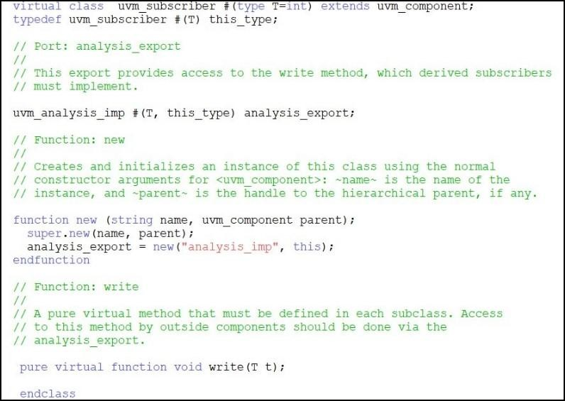

**Fig 7.1.** Uvm_subscriber

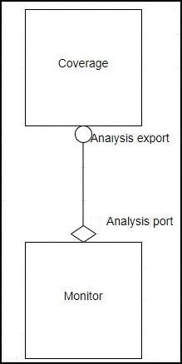

**Fig 7.2.** Monitor and coverage connection

##### Analysis export

This export provides access to the write method, which derived subscribers must implement.

##### Write function

The write function is to process the incoming transactions.

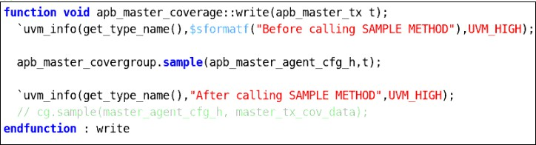

**Fig 7.3** Write function

#### Covergroup

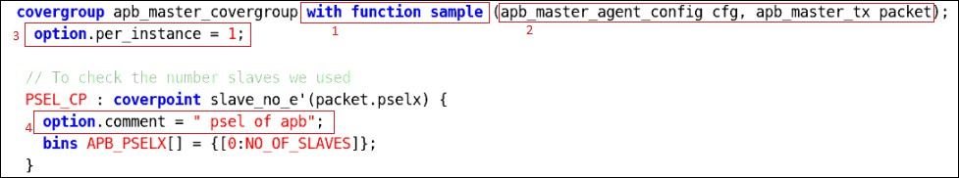

**Fig 7.4.1** Covergroup

The above red mark points in Figure covergroup is explained below :-

1. **With function sample**: - It is used to pass a variable to covergroup.
2. Parameter based on which the coverpoint is generated.
3. **Per Instance Coverage - *'option.per_instance'***

In your test bench, you might have instantiated coverage_group multiple times. By default, System Verilog collects all the coverage data from all the instances. You might have more than one generator and they might generate different streams of transaction. In this case you may want to see separate reports. Using this option, you can keep track of coverage for each instance.

* 1. ***option.per_instance=1*** Each instance contributes to the overall coverage information for the covergroup type. When true, coverage information for this covergroup instance shall be saved in the coverage database and included in the coverage report.



**Figure 7.4.2** option.per_instance

1. **Cover Group Comment - *'option.comment*’**

You can add a comment in to coverage report to make them easier while analyzing:

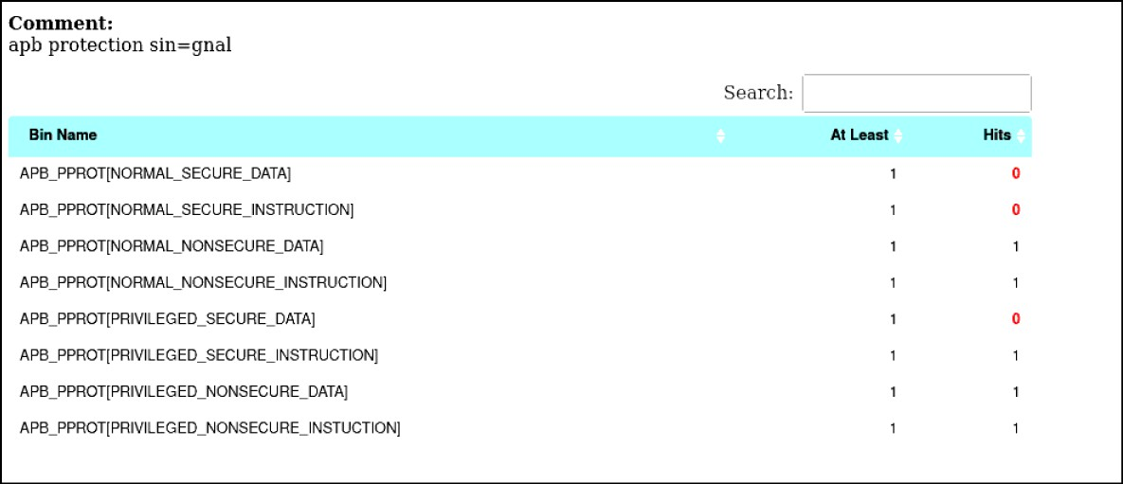

**Fig 7.4.3** option.comment

For example, you could see the usage of 'option.comment' feature. This way you can make the coverage group easier for the analysis.

#### Bucket

In this we create the single bin for the multiple values i.e.



**Fig 7.4.4** Bucket

* In the above 2 points we can see that the Mode[] have the bins for each value.
* In the second W_Delay_Max there is only one bin created for the many values

#### Coverpoints

There we created the bins based on the write and read operation.

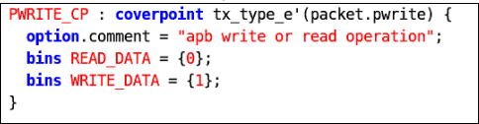

**Fig 7.5** Coverpoint

#### Cross coverpoints

Cross allows keeping track of information which is received simultaneous on more than one cover point. Cross coverage is specified using the cross construct.

Cross coverage between paddr, prdata and pwdata:

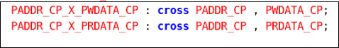

**Fig 7.6** Cross Coverpoints

##### Illegal bins

*illegal_bins illegal_bin = {0};*

Illegal bins are used when we don't want to have the particular value eg - we don't want to have the baud_rate_divisior to be zero so we create the illegal bin for it.

#### Creation of the covergroup

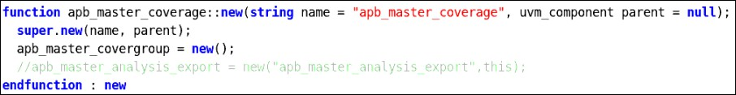

**Fig 7.7** Creation of covergroup

In this function the creation of the covergroup is done with the new as shown in the figure above.

#### Sampling of the covergroup

In this the sampling of the covergroup is done in the write function as shown below

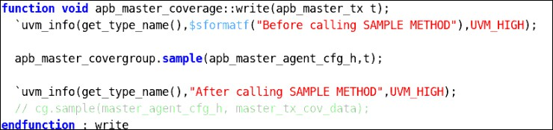

**Fig 7.8** Sampling of the covergroup

#### Registers Coverage

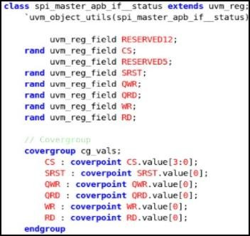

**Fig 7.9** Register coverage class

1. The coverage is basically used to check the scenarios of all the values that are present in the register or the memory.
2. In the RAL the covergroups are declared for each of the registers and the memories.
3. Inside the covergroup we declare the coverpoint for each of the fields that are there in the registers and the memories.

#### The methods for the sampling the values

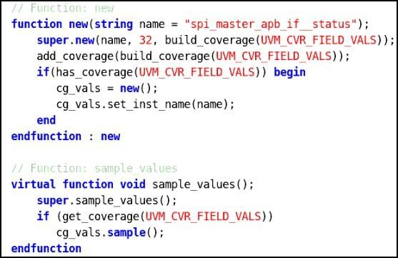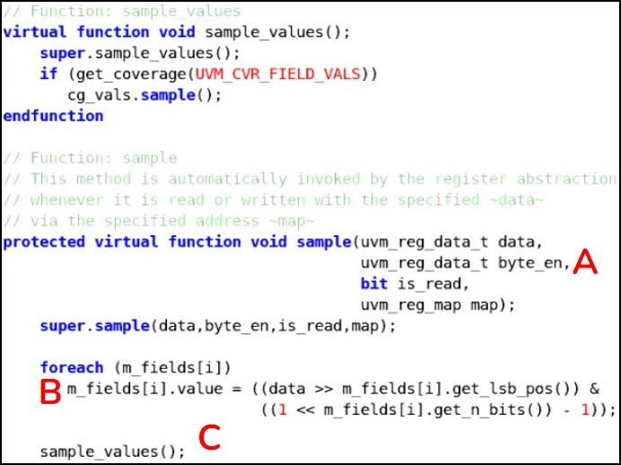

**Fig 7.10.: Sampling of the Coverage values**

1. After the coverage model needs to be constructed for a particular register and the memory via a method function new.
2. A - this represents uvm_reg::sample() function definition and the default uvm_reg::sample() function is empty.
3. B - Thus, to sample the coverage after each register access we need to implement the uvm_reg::sample() function.
4. To make sure the register-field values are updated before sampling the coverage the register-fields are updated manually(Marker B) and then coverage sampling is done(Marker C).

#### Enabling and sampling the coverage

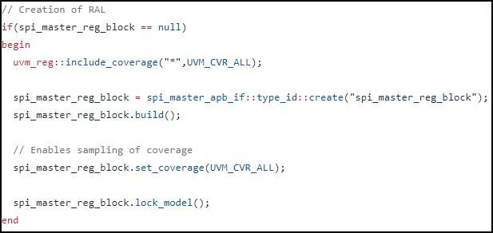

**Fig 7.11** Enabling and Sampling of the Coverage values

1. Before building the reg model we need to set uvm_reg::include_coverage(...) to indicate which models to be constructed and this is done in the test.
2. In this basically we enabling, building and sample coverage.

#### Coverage of all the Register and the memories

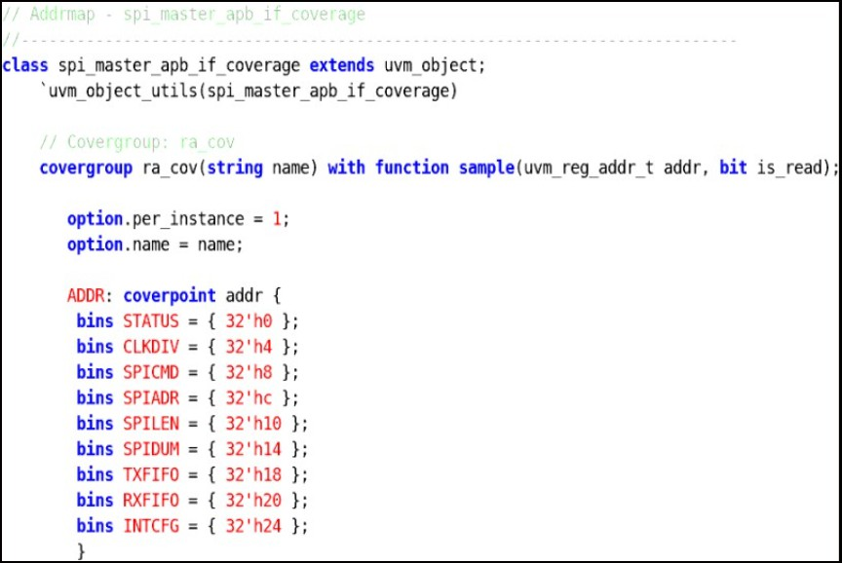

**Fig 7.12** Coverage of the registers

1. In this we declare the covergroup for all the register that is all the address of the register are covered or not
2. we declare the coverpoint with the bins for each of the registers and the memory address .

#### Method for sampling

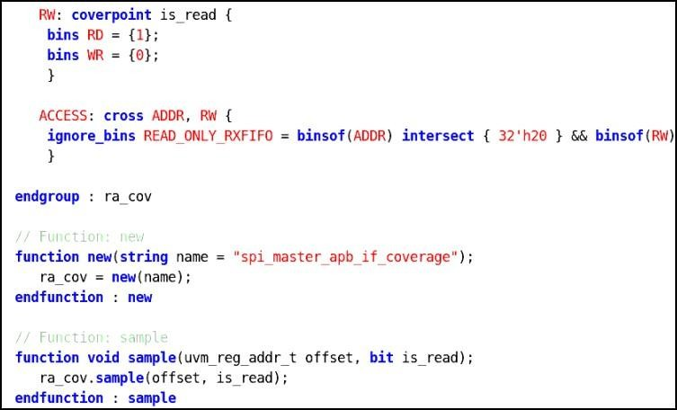

**Fig 7.13 Method to do sampling**

* After all covergroup of the register we declare the covergroup for the entire DUT and check the coverpoints, cross coverpoints in those.
* Then declare the constructor and the sample function for that covergroup.

#### Checking for the coverage

1. Make Compile
2. Make simulate
3. Open the log file



**Fig 7.9.1:** Simulation log file path

1. Search for the coverage (There it will be the full coverage) in the log file.
2. To check the individual coverage bins hit open the coverage report as shown :-



Then new html window will open

**Fig 7.9.2:** Coverage report path

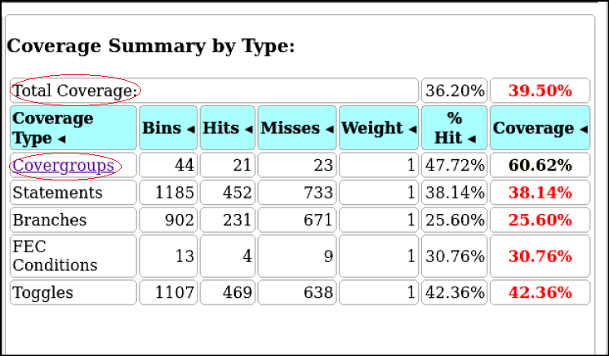

**Fig 7.9.3:** HTML window showing all coverage

Here click on the covergroup there we can see the per instance created and inside that each coverpoint with bins is present there.

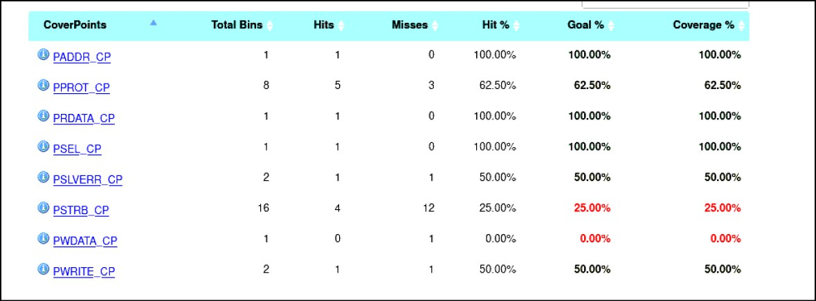

**Fig 8.9.4:** All coverpoints present in the Covergroup

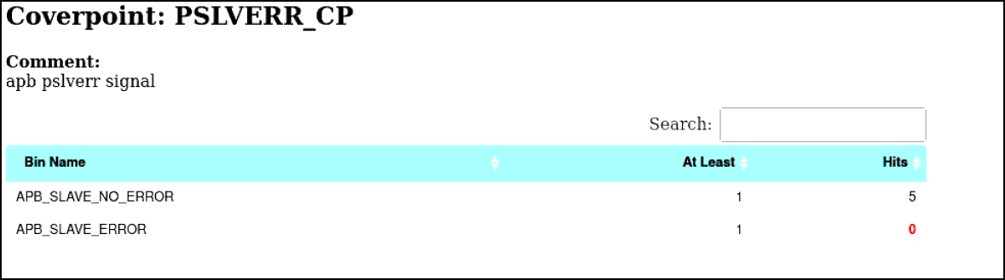

**Figure 7.9.5:** Individual Coverpoint Hit

#### Excluding the bins and covergroup with and without the command line

* The below document explains how to remove the bins and the covergroups:- [Excluding the bins document](https://docs.google.com/document/d/1N2Zgv4qYfd0WCUzvwQxlE4JrFkFVXiSfUxhvyCy6Qag/edit)

### Chapter 8

# Test Cases

#### Test Flow

In the test, there is virtual sequence and in virtual sequence, sequences are there, sequence_item get started in sequences, sequences will start in virtual sequence and virtual sequence will start in test

[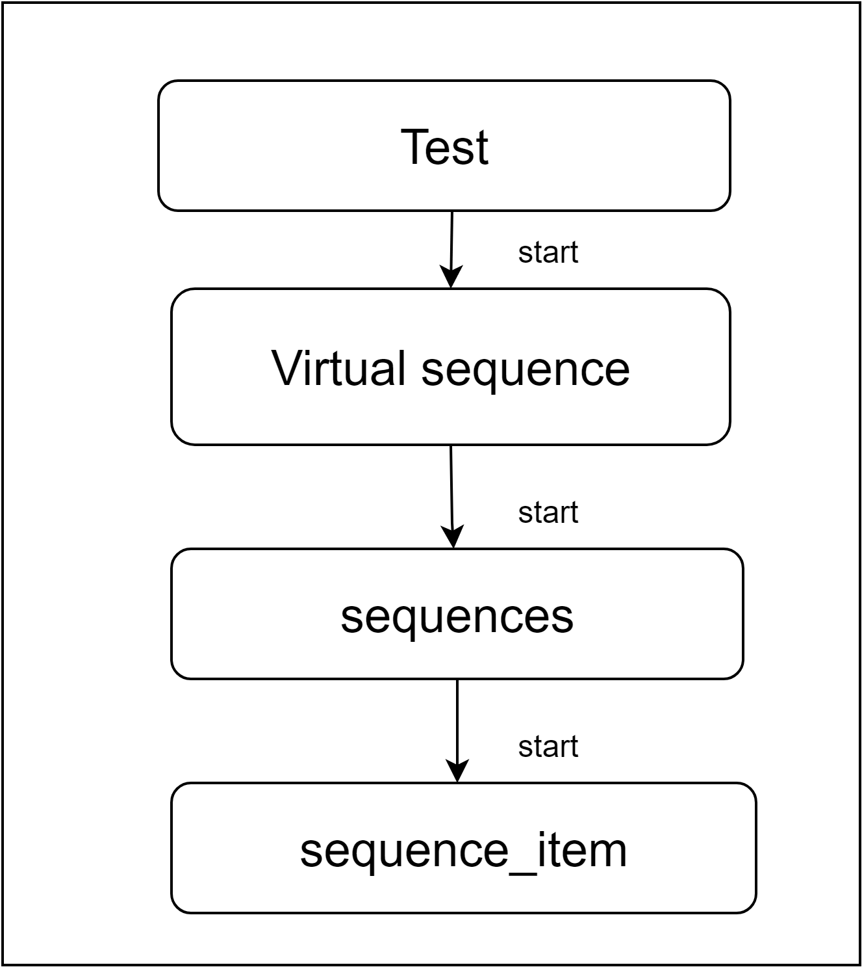](https://app.diagrams.net/?page-id=dnmm31B8M5x43_O-oxbx&scale=auto&G14efqYN0hjCcjijkMFQeD24eAYpKeaZi7)

**Fig 9.1** Test flow

#### Test Cases Flowchart

[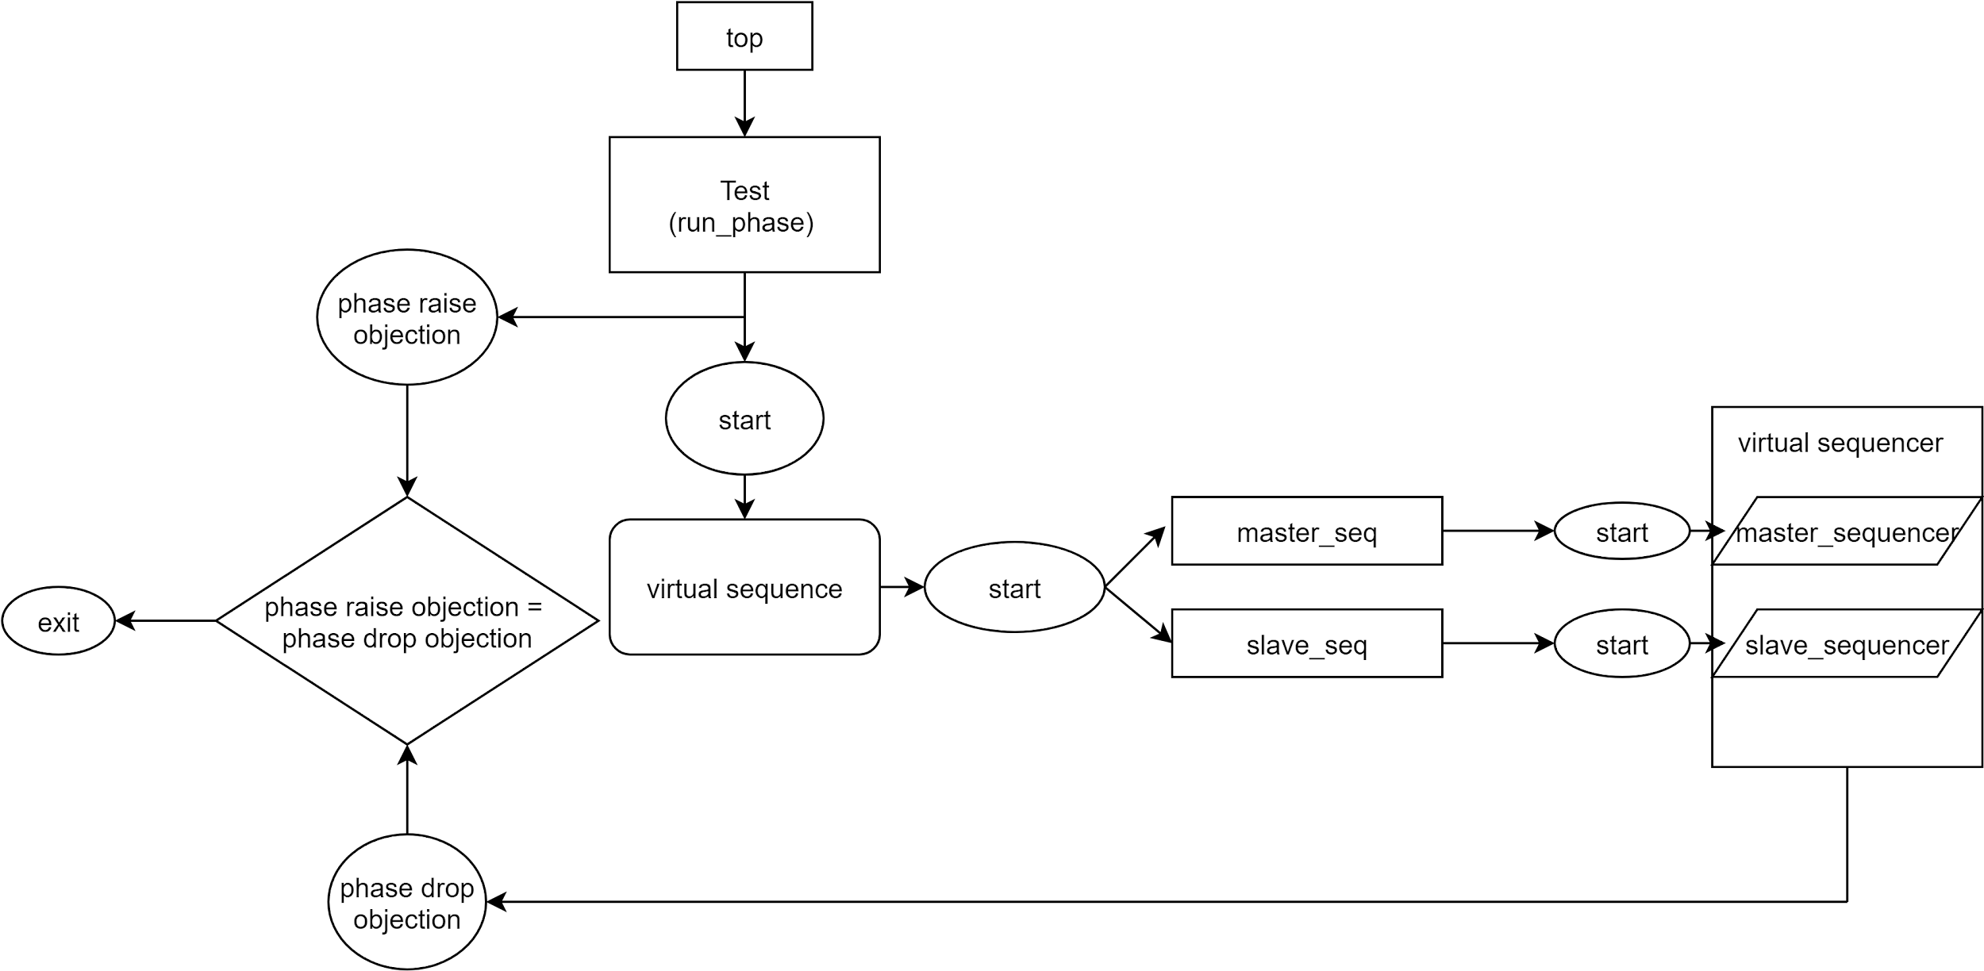](https://app.diagrams.net/?page-id=h55yXCwGjkN_euucidk-&scale=auto&G1O_1yzaDScYo1JUg2S9xWHsM-zdMKJ0o4)

#### Transaction

|  |  |  |
| --- | --- | --- |
| **Variables** | **Type** | **Description** |
| cs | bit | Master asserts the chip select to select the slave device |
| master_out_slave_in | bit | Master Out ⇒ Slave In. Data leaves the master device and enters the slave device. MOSI lines on chip A are connected to MOSI lines on chip B |
| master_in_slave_out | bit | Master In ⇐ Slave Out. Data leaves the slave device and enters the master device (or another slave. MISO lines on chip A are connected to MISO lines on chip B. |

|  |  |  |
| --- | --- | --- |
| **Variables** | **Type** | **Description** |
| pselx | bit | Master asserts the pselx to select the slave device |
| pwrite | enum | Pwrite signal decides whether write data transfer happens from the master side or read data transfer happens to the master. |
| paddr | bit | Address. This is the APB address bus. It can be up to 32 bits wide and is a data access or an instruction access. |
| pprot | enum | Protection type. This signal indicates the normal, privileged, or secure protection level of the transaction and whether the transaction is a data access or an instruction access. |
| penable | bit | Enable.This signal indicates the second and subsequent cycle of an APB transfer. |
| pwdata | bit | Write data. This bus is driven by the peripheral bus bridge unit during the write cycle when pwrite is HIGH. This bus can be up to 32 bits wide. |
| pstrb | enum | Write strobes. This signal indicates when byte lanes to update during a write transfer. There is one write strobe for each eight bits of the write data bus. Therefore, pstrb[n] corresponds to pwdata[(8n+7):(8n)]. Write strobes must not be active during a read transfer. |
| pready | bit | Ready. The Slave uses this signal to extend an APB transfer. |
| prdata | bit | Read Data.The selected slave drives this bus during read cycles when pwrite is LOW. This bus can be up to 32-bits wide. |
| pslverr | enum | This signal indicates a transfer failure. APB peripherals are not required to support the pslverr pin. This is true for both existing and new APB peripheral designs. Where a peripheral does not include this PIN then the appropriate input to the APB bridge is tied LOW. |

##### Master_tx

* + - * Master_tx class is extended from the uvm_sequence_item holds the data items required to drive stimulus to dut.
      * Declared all the variables (pselx, paddr, pwrite, pwdata, pready pslverr, pprot, pstrobe).
      * Constraint declared for slave select and data transfer based on transfer size.

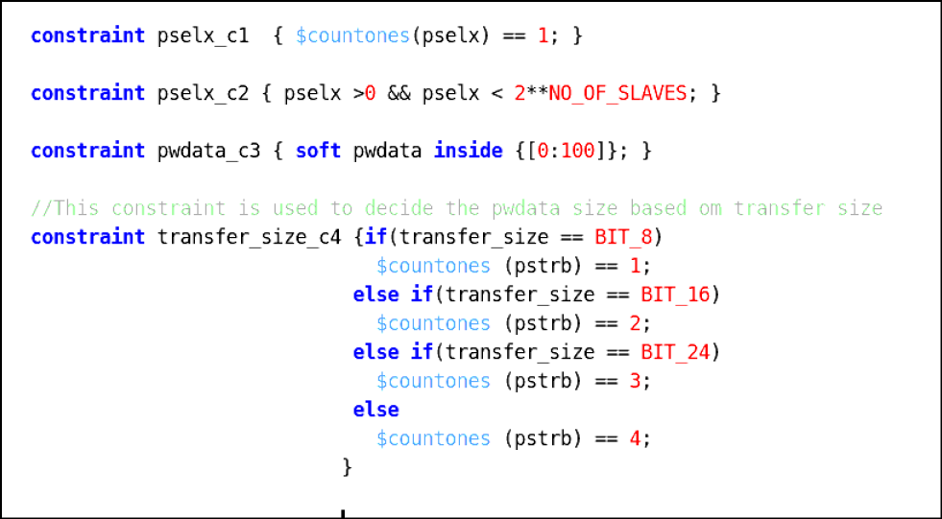

**Fig 8.3** Constraint for pselx and transfer_size

Table 8.3.2 Describing constraint for pselx and transfer size

|  |  |
| --- | --- |
| **Constraint** | **Description** |
| pselx_c1 | Declaring constraint for to select one slave at a time |
| pselx_c2 | Declaring constraint for pselx should be in specified range |
| transfer_size_c4 | This constraint is used to decide the pwdata based on the transfer size. (whether it is 8bit, 16bit, 24bit etc..) |

* + - * Written functions for do_copy, do_compare, do_print methods, $casting is used to copy the data member values and compare the data member values and by using a printer, printing the master tx signals.

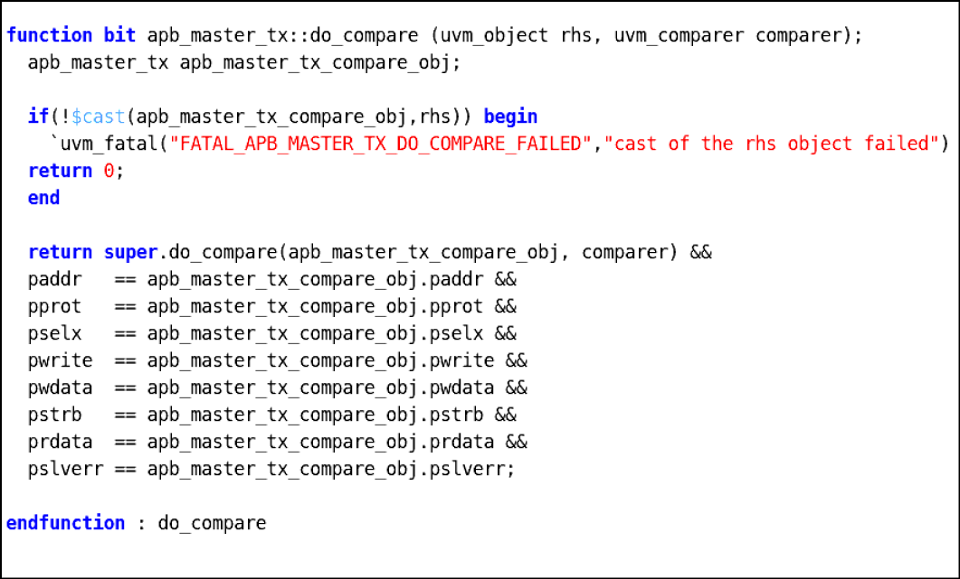

**Fig 8.4** do_compare method

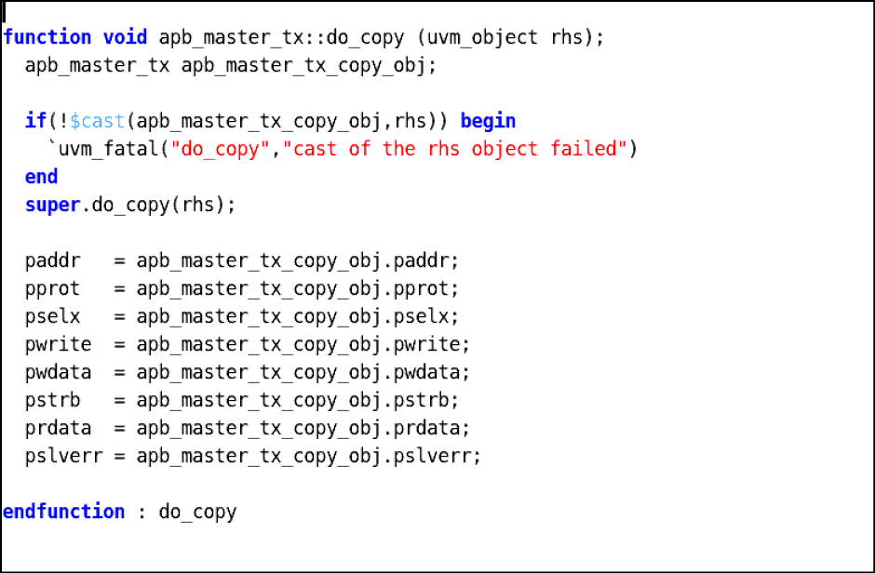

**Fig 8.5** do_copy method

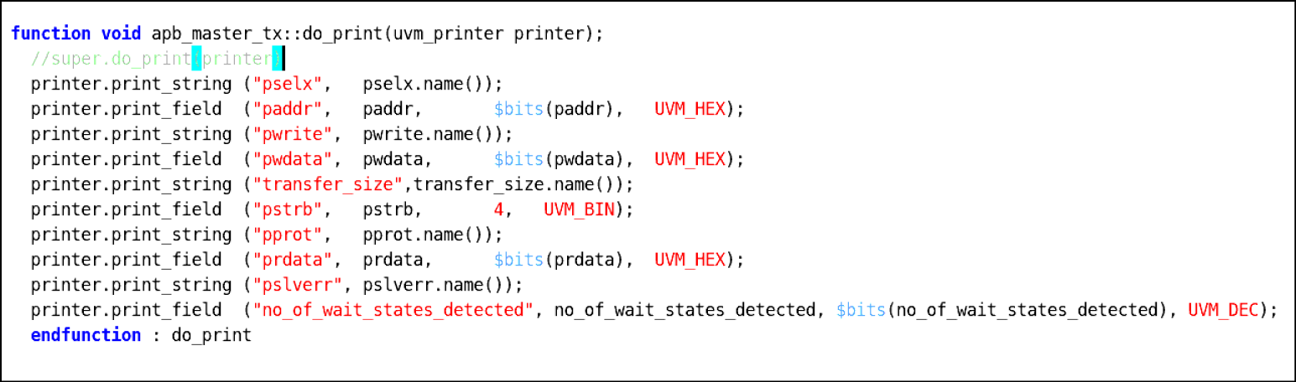

**Fig 8.6** do_print method

##### Slave_tx

* + - * Declared all the variables(cs, MOSI, MISO)
      * Constraint declared for MISO tx data between 0 maximum upto 128 bytes



**Fig 9.7** Constraint for miso

Table 9.3.3 Describing constraint for miso

|  |  |
| --- | --- |
| **Constraint** | **Description** |
| miso_c | Declaring master_in_slave_out value in between 0 and maximum upto 128 bytes(maximum_bits=1024 bits and character_length=8 bits). |

* + - * Written functions for do_copy, do_compare, do_print methods, $casting is used to copy the data member values and compare the data member values and by using a printer , printing the MOSI and MISO values.

#### Sequences

##### Bus Sequences:

A UVM Sequence is an object that contains a behavior for generating stimulus. A sequence generates a series of sequence_ items and sends it to the driver via sequencer, Sequence is written by extending the uvm_sequence.

##### Methods:

|  |  |
| --- | --- |
| **Method** | **Description** |
| new | Creates and initializes a new sequence object |
| start_item | This method will send the request item to the sequencer, which will forward it to the driver |
| req.randomize() | Generate the transaction(seq_item). |
| finish_item | Wait for acknowledgement or response |

[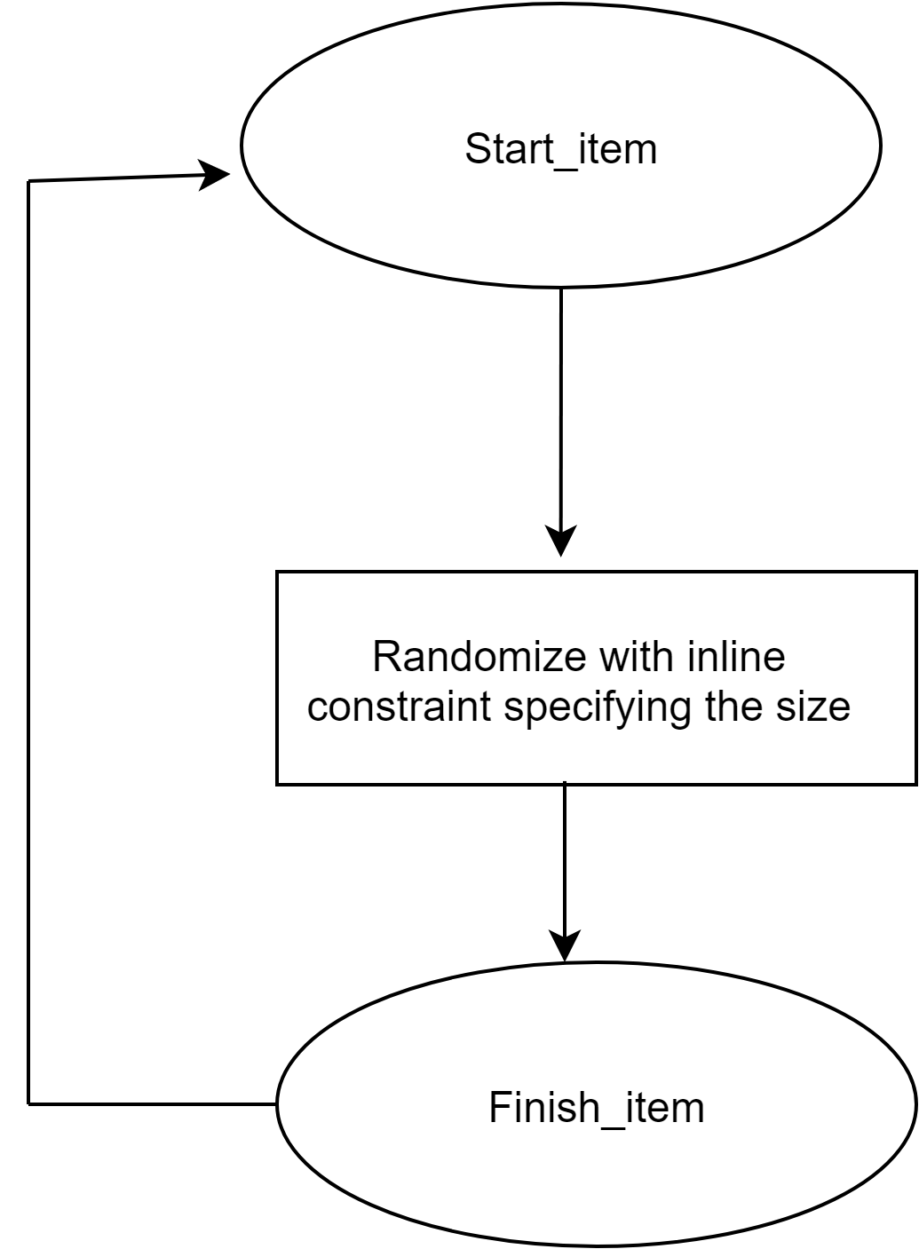](https://app.diagrams.net/?page-id=S8NSsikoFkYFWgU_b_Dg&scale=auto&G1THkiWYGkB8r4PCZdx4fXA2T8loKfydFl)

**Fig 9.8** Flow chart for sequence methods

|  |  |  |  |
| --- | --- | --- | --- |
| **Sections** | **Master sequences** | **Slave sequences** | **Description** |
| base_seq | apb_master_base_seq.sv | spi_slave_base_seq.sv | Base class is extended from uvm_ sequence and parameterized with transaction (apb_master_ tx, spi_slave_ tx) |
| Data transfers and  std mode | apb_master_std_mode_w rite_0_cmd_0_addr_32_d ata_length_seq.sv | spi_fd_basic_slave_seq  .sv | Extended from base sequences. Based on a request from the driver, the task will drive the transactions. In between start_ item and finish_ item using inline constraint and randomizing the master req with the address of each register belongs and wdata for 0 command and 0 address and 32 bit data length that needs to write into registers and in slave randomizing the mosi size.( size is 4 for 32b) |

|  |  |  |  |
| --- | --- | --- | --- |
|  | apb_master_std_mode_w rite_0_cmd_32_addr_32_ data_length_seq.sv | spi_fd_basic_slave_seq  .sv | Extended from base sequences. Based on a request from the driver, the task will drive the transactions. In between start_ item and finish_ item using inline constraint and randomizing the master req with the address of each register belongs and wdata for 0 command length and 32 address length and 32 bit data length that needs to write into registers and in slave randomizing the mosi size.( size is 4 for 32b) |
|  | apb_master_std_mode_w rite_32_cmd_32_addr_32  _data_length_seq.sv | spi_fd_basic_slave_seq  .sv | Extended from base sequences. Based on a request from the driver, the task will drive the transactions. In between start_ item and finish_ item using inline constraint and randomizing the master req with the address of each register belongs and wdata for 32 command length and 32 address length and 32 bit data length that needs to write into registers and in slave randomizing the mosi size.( size is 4 for 32b) |
|  | apb_master_std_mode_w rite_8_cmd_8_addr_32_d ata_length_seq.sv | spi_fd_basic_slave_seq  .sv | Extended from base sequences. Based on a request from the driver, the task will drive the transactions. In between start_ item and finish_ item using inline constraint and randomizing the master req with the address of each register belongs and wdata for 8 command length and 8 address length and 32 bit data length that needs to write into registers and in slave randomizing the mosi size.( size is 4 for 32b) |
| Dummy Cycles | apb_master_std_mode_w rite_0_dummy_write_seq  .sv | spi_fd_basic_slave_seq  .sv | Extended from base sequences. Based on a request from the driver, the task will drive the transactions. In between start_ item and finish_ item using inline constraint and randomizing the master req with the 0 dummy cycles that needs to write into registers and in slave randomizing the mosi size.( size is 4 for 32b) |
|  | apb_master_std_mode_w rite_8_dummy_write_seq  .sv | spi_fd_basic_slave_seq  .sv | Extended from base sequences. Based on a request from the driver, the task will drive the transactions. In between start_ item and finish_ item using inline constraint and randomizing the master req with the 8 dummy cycles that needs to write into registers and in slave randomizing the mosi size.( size is 4 for 32b) |
|  | apb_master_std_mode_w rite_16_dummy_write_se q.sv | spi_fd_basic_slave_seq  .sv | Extended from base sequences. Based on a request from the driver, the task will drive the transactions. In between start_ item and finish_ item using inline constraint and randomizing the master req with the 2 dummy cycles that needs to write into registers and in slave randomizing the mosi size.( size is 4 for 32b) |

|  |  |  |  |
| --- | --- | --- | --- |
| Clock Divider | apb_master_std_mode_w rite_even_clkdiv_seq.sv | spi_fd_basic_slave_seq  .sv | Extended from base sequences. Based on a request from the driver, the task will drive the transactions. In between start_ item and finish_ item using inline constraint and randomizing the master req with the even clock divider that needs to write into registers and in slave randomizing the mosi size.( size is 4 for 32b) |
|  | apb_master_std_mode_w rite_odd_clkdiv_seq.sv | spi_fd_basic_slave_seq  .sv | Extended from base sequences. Based on a request from the driver, the task will drive the transactions. In between start_ item and finish_ item using inline constraint and randomizing the master req with the odd clock divider that needs to write into registers and in slave randomizing the mosi size.( size is 4 for 32b) |
| Interrupt Configurati ons | apb_master_std_mode_w rite_thtx_rhtx_cnttx_cntr x_value_2_seq.sv | spi_fd_basic_slave_seq  .sv | Extended from base sequences. Based on a request from the driver, the task will drive the transactions. In between start_ item and finish_ item using inline constraint and randomizing the master req with the threshold and counter values for both writes and reads that needs to write into registers and in slave randomizing the mosi size.( size is 4 for 32b) |
| Random Sequence | apb_master_rand_seq.sv | spi_fd_basic_slave_seq  .sv | Extended from base sequences. Based on a request from the driver, the task will drive the transactions. In between start_ item and finish_ item using inline constraint and randomizing the master req with the all types of registers for both writes and reads that needs to write into registers and in slave randomizing the mosi size.( size is 4 for 32b) |

In master_seq body creating req and start item will start seq and randomizing the req with inline constraint and selecting slave then print req followed by finish item.

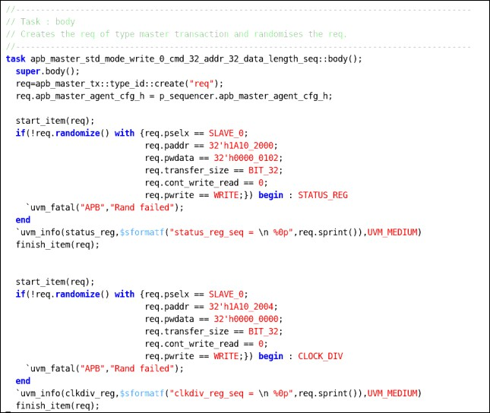

In slave_seq body creating req and start item will start seq and randomizing the req with inline constraint and print req followed by finish item

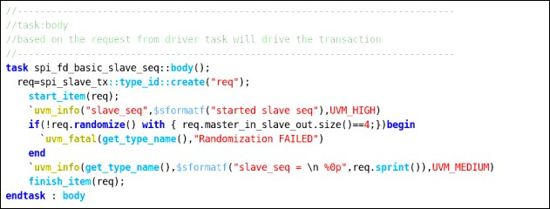

##### Register Sequences

This section defines the sequences used for register stimulus generation.

**uvm_reg_sequence** This class provides base functionality for both

user-defined RegModel test sequences and “register translation sequences”

When used as a base for user-defined RegModel test sequences, this class provides convenience methods for reading and writing registers and memories.

Users implement the body() method to interact directly with the RegModel model or indirectly via the delegation methods in this class.

##### Methods:

|  |  |
| --- | --- |
| **Method** | **Description** |
| new | Creates and initializes a new sequence object |
| Write | Writes the given register *rg* using uvm_reg::write, supplying ‘this’ as the *parent* argument. |
| Read | Reads the given register *rg* using [uvm_reg::read](https://verificationacademy.com/verification-methodology-reference/uvm/docs_1.1b/html/files/reg/uvm_reg-svh.html#uvm_reg.read), supplying ‘this’ as the *parent* argument. |
| Update | Updates the given register *rg* using [uvm_reg::update](https://verificationacademy.com/verification-methodology-reference/uvm/docs_1.1b/html/files/reg/uvm_reg-svh.html#uvm_reg.update), supplying ‘this’ as the *parent* argument. |

**Register Masking:**

Register Masking allows to mask the fields of each register(to be set or to be clear each bit) which are declared in the Register Model.

The below figure shows the define file with the position and mask of each field in the given register

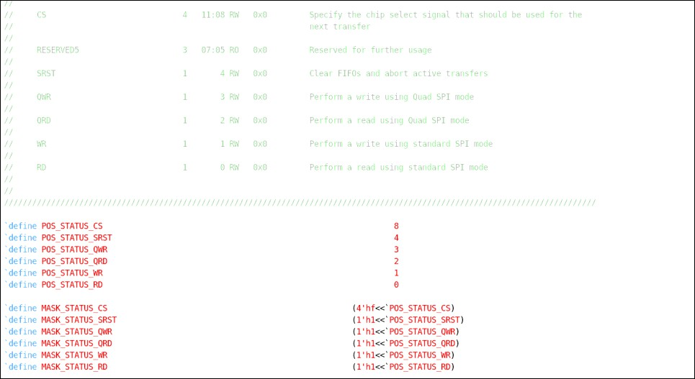

|  |  |  |  |
| --- | --- | --- | --- |
| **Sections** | **Master sequences** | **Slave sequences** | **Description** |
| base_seq | apb_master_base_reg_se q.sv | spi_slave_base_seq.sv | Base class is extended from uvm_reg_ sequence for master and uvm_sequence for slave and both are parameterized with transaction (apb_master_ tx, spi_slave_ tx) |
| Data transfers and  std mode | apb_master_std_mode_w rite_0_cmd_0_addr_16_d ata_length_reg_seq.sv | spi_fd_basic_slave_seq  .sv | Extended from register base sequences. Based on a request from the driver, the task will drive the transactions. Each field of the registers in a register block will be updated with the specified values respectively. In this SPILEN register is updated with 0 cmd and 0 addr and 16 data length. And with the help of adapters it will convert into the reg2bus transactions and in slave randomizing the mosi size.( size is 4 for 32b)  . |
|  | apb_master_std_mode_w rite_0_cmd_16_addr_16_ data_length_reg_seq.sv | spi_fd_basic_slave_seq  .sv | Extended from register base sequences. Based on a request from the driver, the task will drive the transactions. Each field of the registers in a register block will be updated with the specified values respectively. In this SPILEN register is updated with 0 cmd and 16 addr and 16 data length. And with the help of adapters it will convert into the reg2bus transactions and in slave randomizing the mosi size.( size is 4 for 32b) . |

|  |  |  |  |
| --- | --- | --- | --- |
|  | apb_master_std_mode_w rite_0_cmd_0_addr_32_d ata_length_reg_seq.sv | spi_fd_basic_slave_seq  .sv | Extended from register base sequences. Based on a request from the driver, the task will drive the transactions. Each field of the registers in a register block will be updated with the specified values respectively. In this SPILEN register is updated with 0 cmd and 0 addr and 32 data length. And with the help of adapters it will convert into the reg2bus transactions and in slave randomizing the mosi size.( size is 4 for 32b) . |
|  | apb_master_std_mode_w rite_0_cmd_32_addr_32_ data_length_reg_seq.sv | spi_fd_basic_slave_seq  .sv | Extended from register base sequences. Based on a request from the driver, the task will drive the transactions. Each field of the registers in a register block will be updated with the specified values respectively. In this SPILEN register is updated with 0 cmd and 32 addr and 32 data length. And with the help of adapters it will convert into the reg2bus transactions and in slave randomizing the mosi size.( size is 4 for 32b) . |
|  | apb_master_std_mode_w rite_16_cmd_16_addr_16  _data_length_reg_seq.sv | spi_fd_basic_slave_seq  .sv | Extended from register base sequences. Based on a request from the driver, the task will drive the transactions. Each field of the registers in a register block will be updated with the specified values respectively. In this SPILEN register is updated with 16 cmd and 16 addr and 16 data length. And with the help of adapters it will convert into the reg2bus transactions and in slave randomizing the mosi size.( size is 4 for 32b) . |
|  | apb_master_std_mode_w rite_16_cmd_16_addr_32  _data_length_reg_seq.sv | spi_fd_basic_slave_seq  .sv | Extended from register base sequences. Based on a request from the driver, the task will drive the transactions. Each field of the registers in a register block will be updated with the specified values respectively. In this SPILEN register is updated with 16 cmd and 16 addr and 32 data length. And with the help of adapters it will convert into the reg2bus transactions and in slave randomizing the mosi size.( size is 4 for 32b) . |
|  | apb_master_std_mode_w rite_32_cmd_32_addr_32  _data_length_reg_seq.sv | spi_fd_basic_slave_seq  .sv | Extended from register base sequences. Based on a request from the driver, the task will drive the transactions. Each field of the registers in a register block will be updated with the specified values respectively. In this SPILEN register is updated with 32 cmd and 32 addr and 32 data length. And with the help of adapters it will convert into the reg2bus transactions and in slave randomizing the mosi size.( size is 4 for 32b) |

|  |  |  |  |
| --- | --- | --- | --- |
|  | apb_master_std_mode_w rite_8_cmd_16_addr_32_ data_length_reg_seq.sv | spi_fd_basic_slave_seq  .sv | Extended from register base sequences. Based on a request from the driver, the task will drive the transactions. Each field of the registers in a register block will be updated with the specified values respectively. In this SPILEN register is updated with 8 cmd and 16 addr and 32 data length. And with the help of adapters it will convert into the reg2bus transactions and in slave randomizing the mosi size.( size is 4 for 32b) |
|  | apb_master_std_mode_w rite_8_cmd_32_addr_32_ data_length_reg_seq.sv | spi_fd_basic_slave_seq  .sv | Extended from register base sequences. Based on a request from the driver, the task will drive the transactions. Each field of the registers in a register block will be updated with the specified values respectively. In this SPILEN register is updated with 8 cmd and 32 addr and 32 data length. And with the help of adapters it will convert into the reg2bus transactions and in slave randomizing the mosi size.( size is 4 for 32b) |
|  | apb_master_std_mode_w rite_8_cmd_8_addr_32_d ata_length_reg_seq.sv | spi_fd_basic_slave_seq  .sv | Extended from register base sequences. Based on a request from the driver, the task will drive the transactions. Each field of the registers in a register block will be updated with the specified values respectively. In this SPILEN register is updated with 8 cmd and 32 addr and 32 data length. And with the help of adapters it will convert into the reg2bus transactions and in slave randomizing the mosi size.( size is 4 for 32b) |
| Dummy Cycles | apb_master_std_mode_w rite_0_dummy_write_reg  _seq.sv | spi_fd_basic_slave_seq  .sv | Extended from register base sequences. Based on a request from the driver, the task will drive the transactions. Each field of the registers in a register block will be updated with the specified values respectively. In this SPIDUM register is updated with 0 write dummy cycles. And with the help of adapters it will convert into the reg2bus transactions and in slave randomizing the mosi size.( size is 4 for 32b) |
|  | apb_master_std_mode_w rite_8_dummy_write_reg  _seq.sv | spi_fd_basic_slave_seq  .sv | Extended from register base sequences. Based on a request from the driver, the task will drive the transactions. Each field of the registers in a register block will be updated with the specified values respectively. In this SPIDUM register is updated with 8 write dummy cycles. And with the help of adapters it will convert into the reg2bus transactions and in slave randomizing the mosi size.( size is 4 for 32b) |

|  |  |  |  |
| --- | --- | --- | --- |
|  | apb_master_std_mode_w rite_16_dummy_write_re g_seq.sv | spi_fd_basic_slave_seq  .sv | Extended from register base sequences. Based on a request from the driver, the task will drive the transactions. Each field of the registers in a register block will be updated with the specified values respectively. In this SPIDUM register is updated with 16 write dummy cycles. And with the help of adapters it will convert into the reg2bus transactions and in slave randomizing the mosi size.( size is 4 for 32b) |
| Clock Divider | apb_master_std_mode_w rite_even_clkdiv_reg_seq  .sv | spi_fd_basic_slave_seq  .sv | Extended from register base sequences. Based on a request from the driver, the task will drive the transactions. Each field of the registers in a register block will be updated with the specified values respectively. In this CLKDIV register is updated with even divisor value. And with the help of adapters it will convert into the reg2bus transactions and in slave randomizing the mosi size.( size is 4 for 32b) |
| Random Sequence | apb_master_rand_reg_se q.sv | spi_fd_basic_slave_seq  .sv | Extended from register base sequences. Based on a request from the driver, the task will drive the transactions. Each field of the registers in a register block will be updated with the specified values respectively. Here all the registers in the register model are randomized. And with the help of adapters it will convert into the reg2bus transactions and in slave randomizing the mosi size.( size is 4 for 32b) |

Master_seq body holds the handle for user defined register model and cast the default or parent register model handle with the child or user defined register model handle and it also has the handle for register map which has the access to all the register addresses along with that it contains wdata and rdata both of register type. And in this the actual masking of each bit or the certain value can be done as shown in below figs…..

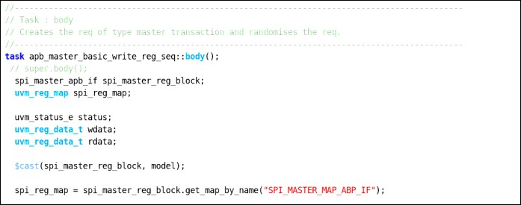

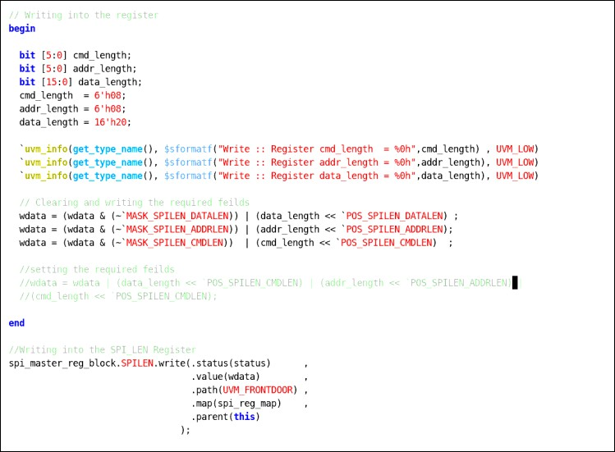

#### Virtual Sequences

A virtual sequence is a container to start multiple sequences on different sequencers in the environment. This virtual sequence is usually executed by a virtual sequencer which has handles to real sequencers. This need for a virtual sequence arises when you require different sequences to be run on different environments.

##### Virtual sequence base class

Virtual sequence base class is extended from uvm_sequence and parameterized with uvm_transaction. Declaring p_sequencer as macro , handles virtual sequencer and master, slave sequencer and environment config.

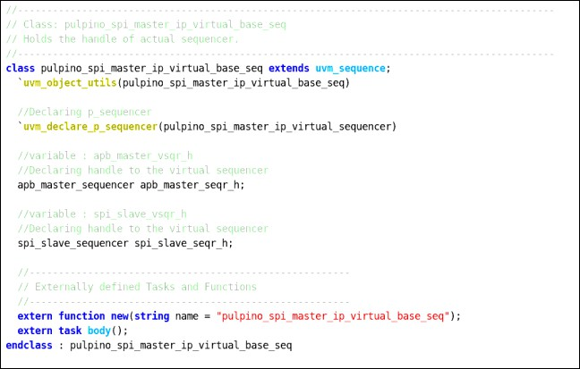

In virtual sequence body method,Getting the env configurations and Dynamic casting of p_sequencer and m_sequencer. Connect the master sequencer and slave sequencer in sequencer with local master sequencer and slave sequencer.

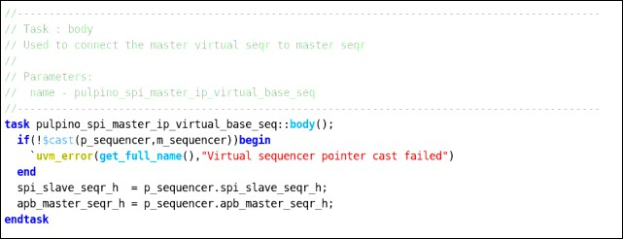

In the virtual sequence body method, creating master and slave sequence handles and starts the slave sequence within fork join_none and master sequence within repeat statement.

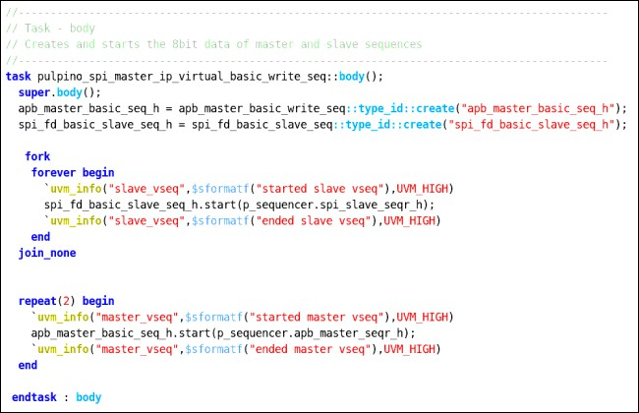

For register sequences in virtual sequence we try to connect the default register block handle with the main register block handle which is inside the environment with the help of p_sequencer.

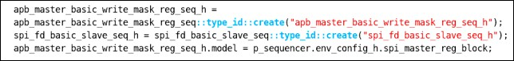

|  |  |  |
| --- | --- | --- |
| **Sections** | **Virtual sequences** | **Description** |
| Data transfer | pulpino_spi_master_ip_v irtual_std_mode_write_0  _cmd_0_addr_32_data_le ngth_reg_seq.sv | Inside the std_mode_write_0_cmd_0_addr_32_data_length_reg virtual sequence, extending from base class.  Declaring handles of sequences and inside body method constructing handles of sequence and Connecting the sequence default register model handle with the actual register model using p_sequencer. And starting the master and slave sequences on the real master and slave sequencers. |

|  |  |  |
| --- | --- | --- |
|  | pulpino_spi_master_ip_v irtual_std_mode_write_1 6_cmd_16_addr_16_data  _length_reg_seq.sv | Inside the std_mode_write_16_cmd_16_addr_16_data_length_reg virtual sequence, extending from base class.  Declaring handles of sequences and inside body method constructing handles of sequence and Connecting the sequence default register model handle with the actual register model using p_sequencer. And starting the master and slave sequences on the real master and slave sequencers. |
|  | pulpino_spi_master_ip_v irtual_std_mode_write_1 6_cmd_16_addr_32_data  _length_reg_seq.sv | Inside the std_mode_write_16_cmd_16_addr_32_data_length_reg virtual sequence, extending from base class.  Declaring handles of sequences and inside body method constructing handles of sequence and Connecting the sequence default register model handle with the actual register model using p_sequencer. And starting the master and slave sequences on the real master and slave sequencers. |
|  | pulpino_spi_master_ip_v irtual_std_mode_write_0  _cmd_0_addr_16_data_le ngth_reg_seq.sv | Inside the std_mode_write_0_cmd_0_addr_16_data_length_reg virtual sequence, extending from base class.  Declaring handles of sequences and inside body method constructing handles of sequence and Connecting the sequence default register model handle with the actual register model using p_sequencer. And starting the master and slave sequences on the real master and slave sequencers |
|  | pulpino_spi_master_ip_v irtual_std_mode_write_0  _cmd_16_addr_16_data_ length_reg_seq.sv | Inside the std_mode_write_0_cmd_16_addr_16_data_length_reg virtual sequence, extending from base class.  Declaring handles of sequences and inside body method constructing handles of sequence and Connecting the sequence default register model handle with the actual register model using p_sequencer. And starting the master and slave sequences on the real master and slave sequencers |
|  | pulpino_spi_master_ip_v irtual_std_mode_write_0  _cmd_32_addr_32_data_ length_reg_seq.sv | Inside the std_mode_write_0_cmd_32_addr_32_data_length_reg virtual sequence, extending from base class.  Declaring handles of sequences and inside body method constructing handles of sequence and Connecting the sequence default register model handle with the actual register model using p_sequencer. And starting the master and slave sequences on the real master and slave sequencers. |
|  | pulpino_spi_master_ip_v irtual_std_mode_write_3 2_cmd_32_addr_32_data  _length_reg_seq.sv | Inside the std_mode_write_32_cmd_32_addr_32_data_length_reg virtual sequence, extending from base class.  Declaring handles of sequences and inside body method constructing handles of sequence and Connecting the sequence default register model handle with the actual register model using p_sequencer. And starting the master and slave sequences on the real master and slave sequencers. |
|  | pulpino_spi_master_ip_v irtual_std_mode_write_8  _cmd_16_addr_32_data_ length_reg_seq.sv | Inside the std_mode_write_8_cmd_16_addr_32_data_length_reg virtual sequence, extending from base class.  Declaring handles of sequences and inside body method constructing handles of sequence and Connecting the sequence default register model handle with the actual register model using p_sequencer. And starting the master and slave sequences on the real master and slave sequencers. |

|  |  |  |
| --- | --- | --- |
|  | pulpino_spi_master_ip_v irtual_std_mode_write_8  _cmd_32_addr_32_data_ length_reg_seq.sv | Inside the std_mode_write_8_cmd_32_addr_32_data_length_reg virtual sequence, extending from base class.  Declaring handles of sequences and inside body method constructing handles of sequence and Connecting the sequence default register model handle with the actual register model using p_sequencer. And starting the master and slave sequences on the real master and slave sequencers. |
|  | pulpino_spi_master_ip_v irtual_std_mode_write_8  _cmd_8_addr_32_data_le ngth_reg_seq.sv | Inside the std_mode_write_8_cmd_8_addr_32_data_length_reg virtual sequence, extending from base class.  Declaring handles of sequences and inside body method constructing handles of sequence and Connecting the sequence default register model handle with the actual register model using p_sequencer. And starting the master and slave sequences on the real master and slave sequencers. |
| Clock Divider | pulpino_spi_master_ip_v irtual_std_mode_write_e ven_clkdiv_reg_seq.sv | Inside the std_mode_write_even_clockdiv_reg virtual sequence, extending from base class.  Declaring handles of sequences and inside body method constructing handles of sequence and Connecting the sequence default register model handle with the actual register model using p_sequencer. And starting the master and slave sequences on the real master and slave sequencers. |
|  | pulpino_spi_master_ip_v irtual_std_mode_write_o dd_clkdiv_seq.sv | Inside the std_mode_write_odd_clockdiv_reg virtual sequence, extending from base class.  Declaring handles of sequences and inside body method constructing handles of sequence and Connecting the sequence default register model handle with the actual register model using p_sequencer. And starting the master and slave sequences on the real master and slave sequencers. |
| Dummy Cycles | pulpino_spi_master_ip_v irtual_std_mode_write_0  _dummy_write_seq.sv | Inside the std_mode_write_0_dummy_write_reg virtual sequence, extending from base class.  Declaring handles of sequences and inside body method constructing handles of sequence and Connecting the sequence default register model handle with the actual register model using p_sequencer. And starting the master and slave sequences on the real master and slave sequencers. |
|  | pulpino_spi_master_ip_v irtual_std_mode_write_1 6_dummy_write_seq.sv | Inside the std_mode_write_16_dummy_write_reg virtual sequence, extending from base class.  Declaring handles of sequences and inside body method constructing handles of sequence and Connecting the sequence default register model handle with the actual register model using p_sequencer. And starting the master and slave sequences on the real master and slave sequencers. |
|  | pulpino_spi_master_ip_v irtual_std_mode_write_8  _dummy_write_seq.sv | Inside the std_mode_write_8_dummy_write_reg virtual sequence, extending from base class.  Declaring handles of sequences and inside body method constructing handles of sequence and Connecting the sequence default register model handle with the actual register model using p_sequencer. And starting the master and slave sequences on the real master and slave sequencers. |

#### Test Cases

The uvm_test class defines the test scenario and verification goals.

1. In base test, declaring the handles for environment config and environment class.

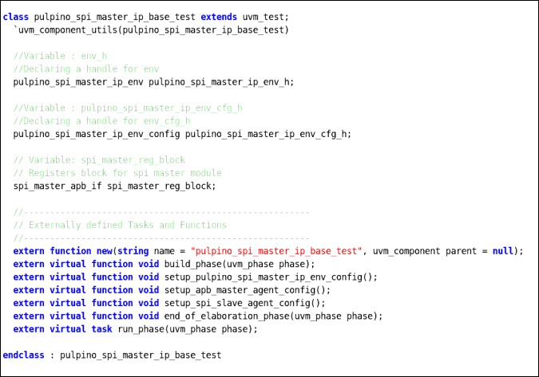

1. In build phase, calling the setup_env_cfg and constructing the environment handle
2. Inside setup_env_cfg function, constructing the environment config class handle. With the help of this env_cfg_h handle all the required fields in the config class have been set up with respective values and then calling the setup_master_agent_config and setup_slave_agent_config functions and creating the RAL model register block and enabling the coverage model in register block by calling the set_coverage function.

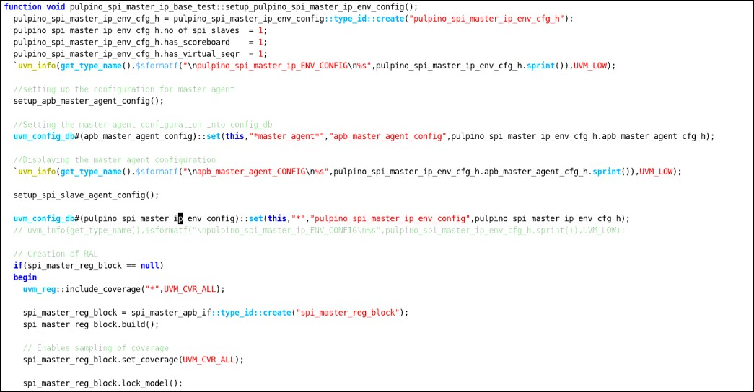

1. In setup_master_agent_config function, master_agent_config class handle which is in env_config class has been constructed with the help of this handle all the required fields(has_coverage,no.of slaves,is_active) in master_agent_config class has been setup.

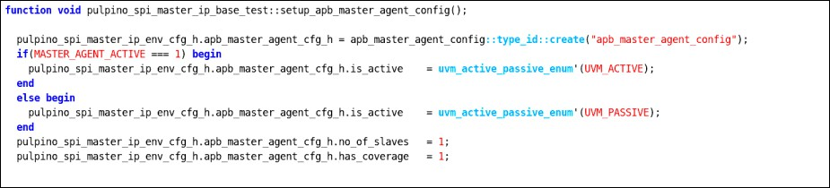

1. In setup_slave_agent_config function, for each slave agent configuration trying to construct slave_agent_config class handle which is in env_config class with the help of this handle all the required fields(slave_id,shift_directions,spi_mode,has_coverage,is_active) in slave_agent_config class has been setup followed by the end of the elaboration phase used to print the topology.

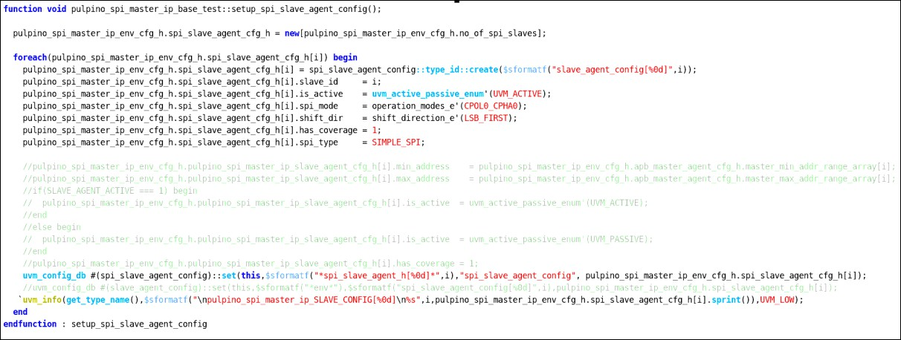

Extend the pulpino_spi_master_ip_std_mode_write_even_clkdiv_test from base test and declare virtual sequence handle then create virtual sequence in test, and start the virtual sequence in phase, raise and drop objection.

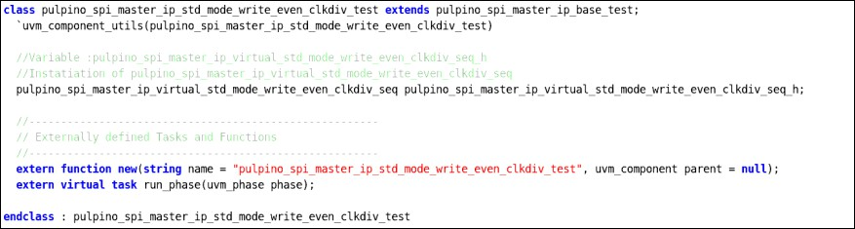

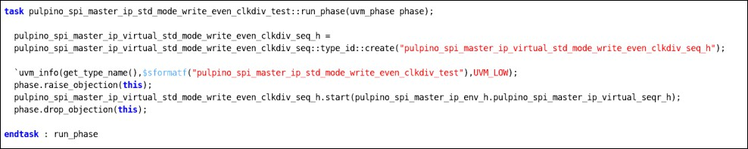

|  |  |  |
| --- | --- | --- |
| **sections** | **Test Names** | **Description** |
| Data transfers | pulpino_spi_master_ip_std_mode_wr ite_0_cmd_0_addr_16_data_length_r eg_test.sv | Extend test from base test and declare virtual sequence then create virtual sequence in run_phase, and start the virtual sequence with virtual sequencer handle in phase, raise and drop objections.  The data 0 cmd and 0 addr and 16 bit data length |

|  |  |  |
| --- | --- | --- |
|  | pulpino_spi_master_ip_std_mode_wr ite_0_cmd_0_addr_32_data_length_r eg_test.sv | Extend test from base test and declare virtual sequence then create virtual sequence in run_phase, and start the virtual sequence with virtual sequencer handle in phase, raise and drop objections.  The data contains 0 cmd and 0 addr and 32 bit data length |
|  | pulpino_spi_master_ip_std_mode_wr ite_0_cmd_16_addr_16_data_length_ reg_test.sv | Extend test from base test and declare virtual sequence then create virtual sequence in run_phase, and start the virtual sequence with virtual sequencer handle in phase, raise and drop objections.  The data contains 0 cmd and 16 bit addr and 16 bit data length |
|  | pulpino_spi_master_ip_std_mode_wr ite_0_cmd_32_addr_32_data_length_ reg_test.sv | Extend test from base test and declare virtual sequence then create virtual sequence in run_phase, and start the virtual sequence with virtual sequencer handle in phase, raise and drop objections.  The data contains 0 cmd and 16 bit addr and 16 bit data length |
|  | pulpino_spi_master_ip_std_mode_wr ite_16_cmd_16_addr_32_data_length  _reg_test.sv | Extend test from base test and declare virtual sequence then create virtual sequence in run_phase, and start the virtual sequence with virtual sequencer handle in phase, raise and drop objections.  The data contains 16 cmd and 16 addr and 32 bit data length |
|  | pulpino_spi_master_ip_std_mode_wr ite_16_cmd_16_addr_16_data_length  _reg_test.sv | Extend test from base test and declare virtual sequence then create virtual sequence in run_phase, and start the virtual sequence with virtual sequencer handle in phase, raise and drop objections.  The data contains 16 cmd and 16 addr and 16 bit data length |
|  | pulpino_spi_master_ip_std_mode_wr ite_32_cmd_32_addr_32_data_length  _reg_test.sv | Extend test from base test and declare virtual sequence then create virtual sequence in run_phase, and start the virtual sequence with virtual sequencer handle in phase, raise and drop objections.  The data contains 32 cmd and 32 addr and 32 bit data length |
|  | pulpino_spi_master_ip_std_mode_wr ite_8_cmd_16_addr_32_data_length_ reg_test.sv | Extend test from base test and declare virtual sequence then create virtual sequence in run_phase, and start the virtual sequence with virtual sequencer handle in phase, raise and drop objections.  The data contains 8 cmd and 16 addr and 32 bit data length |

|  |  |  |
| --- | --- | --- |
|  | pulpino_spi_master_ip_std_mode_wr ite_8_cmd_32_addr_32_data_length_ reg_test.sv | Extend test from base test and declare virtual sequence then create virtual sequence in run_phase, and start the virtual sequence with virtual sequencer handle in phase, raise and drop objections.  The data contains 8 cmd and 32 addr and 32 bit data length |
|  | pulpino_spi_master_ip_std_mode_wr ite_8_cmd_8_addr_32_data_length_r eg_test.sv | Extend test from base test and declare virtual sequence then create virtual sequence in run_phase, and start the virtual sequence with virtual sequencer handle in phase, raise and drop objections.  The data contains 8 cmd and 8 addr and 32 bit data length |
| Clock Divider | pulpino_spi_master_ip_std_mode_wr ite_even_clkdiv_reg_test.sv | Extend test from base test and declare virtual sequence then create virtual sequence in run_phase, and start the virtual sequence with virtual sequencer handle in phase, raise and drop objections.  The data contains 32 bit data for even clock divider |
|  | pulpino_spi_master_ip_std_mode_wr ite_odd_clkdiv_reg_test.sv | Extend test from base test and declare virtual sequence then create virtual sequence in run_phase, and start the virtual sequence with virtual sequencer handle in phase, raise and drop objections.  The data contains 32 bit data for odd clock divider |
| Dummy Cycles | pulpino_spi_master_ip_std_mode_wr ite_0_dummy_write_reg_test.sv | Extend test from base test and declare virtual sequence then create virtual sequence in run_phase, and start the virtual sequence with virtual sequencer handle in phase, raise and drop objections.  The data contains 32 bit data for 0 dummy write cycle |
|  | pulpino_spi_master_ip_std_mode_wr ite_8_dummy_read_reg_test.sv | Extend test from base test and declare virtual sequence then create virtual sequence in run_phase, and start the virtual sequence with virtual sequencer handle in phase, raise and drop objections.  The data contains 32 bit data for 2 dummy write cycle |
|  | pulpino_spi_master_ip_std_mode_wr ite_16_dummy_read_reg_test.sv | Extend test from base test and declare virtual sequence then create virtual sequence in run_phase, and start the virtual sequence with virtual sequencer handle in phase, raise and drop objections.  The data contains 32 bit data for 16 dummy write cycle |
| Interrupt Configurations | pulpino_spi_master_ip_std_mode_re ad_thtx_rhtx_cnttx_cntrx_value_2_re g_test.sv | Extend test from base test and declare virtual sequence then create virtual sequence in run_phase, and start the virtual sequence with virtual sequencer handle in phase, raise and drop objections.  The data contains 32 bit data for transmitter and receiver fifos |

|  |  |  |
| --- | --- | --- |
| tx_fifo | pulpino_spi_master_ip_std  _mode_write_tx_fifo_reg_t est.sv | Extend test from base test and declare virtual sequence then create virtual sequence in run_phase, and start the virtual sequence with virtual sequencer handle in phase, raise and drop objections.  The data contains 32 bit data for transmitter fifos |

#### Testlists

Regression list for Pulpino spi master ip Verification

Table 6.7 Testlists

|  |  |
| --- | --- |
| **TestCase Names** | **Description** |
| pulpino_spi_master_ip_basic_write_reg_test | Checks for standard mode write spi transfers |
| pulpino_spi_master_ip_basic_write_read_reg_test | Checks for standard mode write read spi transfers |
| pulpino_spi_master_ip_rand_reg_test | Checks for random register values of each register |
| pulpino_spi_master_ip_std_mode_read_0_dummy_read_reg_te st | Checks for standard mode read with 0 dummy read cycles |
| pulpino_spi_master_ip_std_mode_read_8_dummy_read_reg_te st | Checks for standard mode read with 8 dummy read cycles |
| pulpino_spi_master_ip_std_mode_read_even_clkdiv_reg_test | Checks for standard mode read with even clock divider |
| pulpino_spi_master_ip_std_mode_read_odd_clkdiv_reg_test | Checks for standard mode read with odd clock divider |
| pulpino_spi_master_ip_std_mode_write_0_cmd_0_addr_32_da ta_length_reg_test | Checks for standard mode write with 0 command bits and 0 address bits and 32 data bits |
| pulpino_spi_master_ip_std_mode_write_0_cmd_0_addr_16_da ta_length_reg_test | Checks for standard mode write with 0 command bits and 0 address bits and 16 data bits |
| pulpino_spi_master_ip_std_mode_write_0_cmd_16_addr_16_d ata_length_reg_test | Checks for standard mode write with 0 command bits and 16 address bits and 16 data bits |
| pulpino_spi_master_ip_std_mode_write_16_cmd_16_addr_16_ data_length_reg_test | Checks for standard mode write with 16 command bits and 16 address bits and 16 data bits |
| pulpino_spi_master_ip_std_mode_write_8_cmd_8_addr_32_da ta_length_reg_test | Checks for standard mode write with 8 command bits and 8 address bits and 16 data bits |
| pulpino_spi_master_ip_std_mode_write_8_cmd_32_addr_32_d ata_length_reg_test | Checks for standard mode write with 8 command bits and 32 address bits and 32 data bits |
| pulpino_spi_master_ip_std_mode_write_16_cmd_16_addr_32_ data_length_reg_test | Checks for standard mode write with 16 command bits and 16 address bits and 32 data bits |
| pulpino_spi_master_ip_std_mode_write_8_cmd_16_addr_32_d ata_length_reg_test | Checks for standard mode write with 8 command bits and 16 address bits and 32 data bits |
| pulpino_spi_master_ip_std_mode_write_0_cmd_32_addr_32_d | Checks for standard mode write with 0 command bits and |

|  |  |
| --- | --- |
| ata_length_reg_test | 32 address bits and 32 data bits |
| pulpino_spi_master_ip_std_mode_write_32_cmd_32_addr_32_ data_length_reg_test | Checks for standard mode write with 32 command bits and 32 address bits and 32 data bits |
| pulpino_spi_master_ip_std_mode_write_tx_fifo_reg_test | Checks for standard mode write with transmitter fifo data |
| pulpino_spi_master_ip_std_mode_write_0_dummy_write_reg_ test | Checks for standard mode write with 0 dummy write cycles |
| pulpino_spi_master_ip_std_mode_write_8_dummy_write_test | Checks for standard mode write with 8 dummy write cycles |
| pulpino_spi_master_ip_std_mode_write_16_dummy_write_test | Checks for standard mode write with 16 dummy write cycles |
| pulpino_spi_master_ip_spi_modes_clkdiv_dummy_cycles_cros s_reg_test | Checks for cross between different SPI modes with different CLKDIV and different Dummy cycles |
| pulpino_spi_master_ip_spi_modes_transfer_length_interupts_c ross_reg_test | Checks for cross between SPI modes and different spi lengths and different interrupts |

# User Guide

The user guide is the document that explains how to run tests on different platforms like Questa sim, cadence, and synopsis and also explains how to view waves, coverage.

PULPINO_SPI_MASTER_IP_VERIFICATION_USER_GUIDE

# References